AWS Task 3:

Sign into AWS account.

Through research bar Looking for Lambda

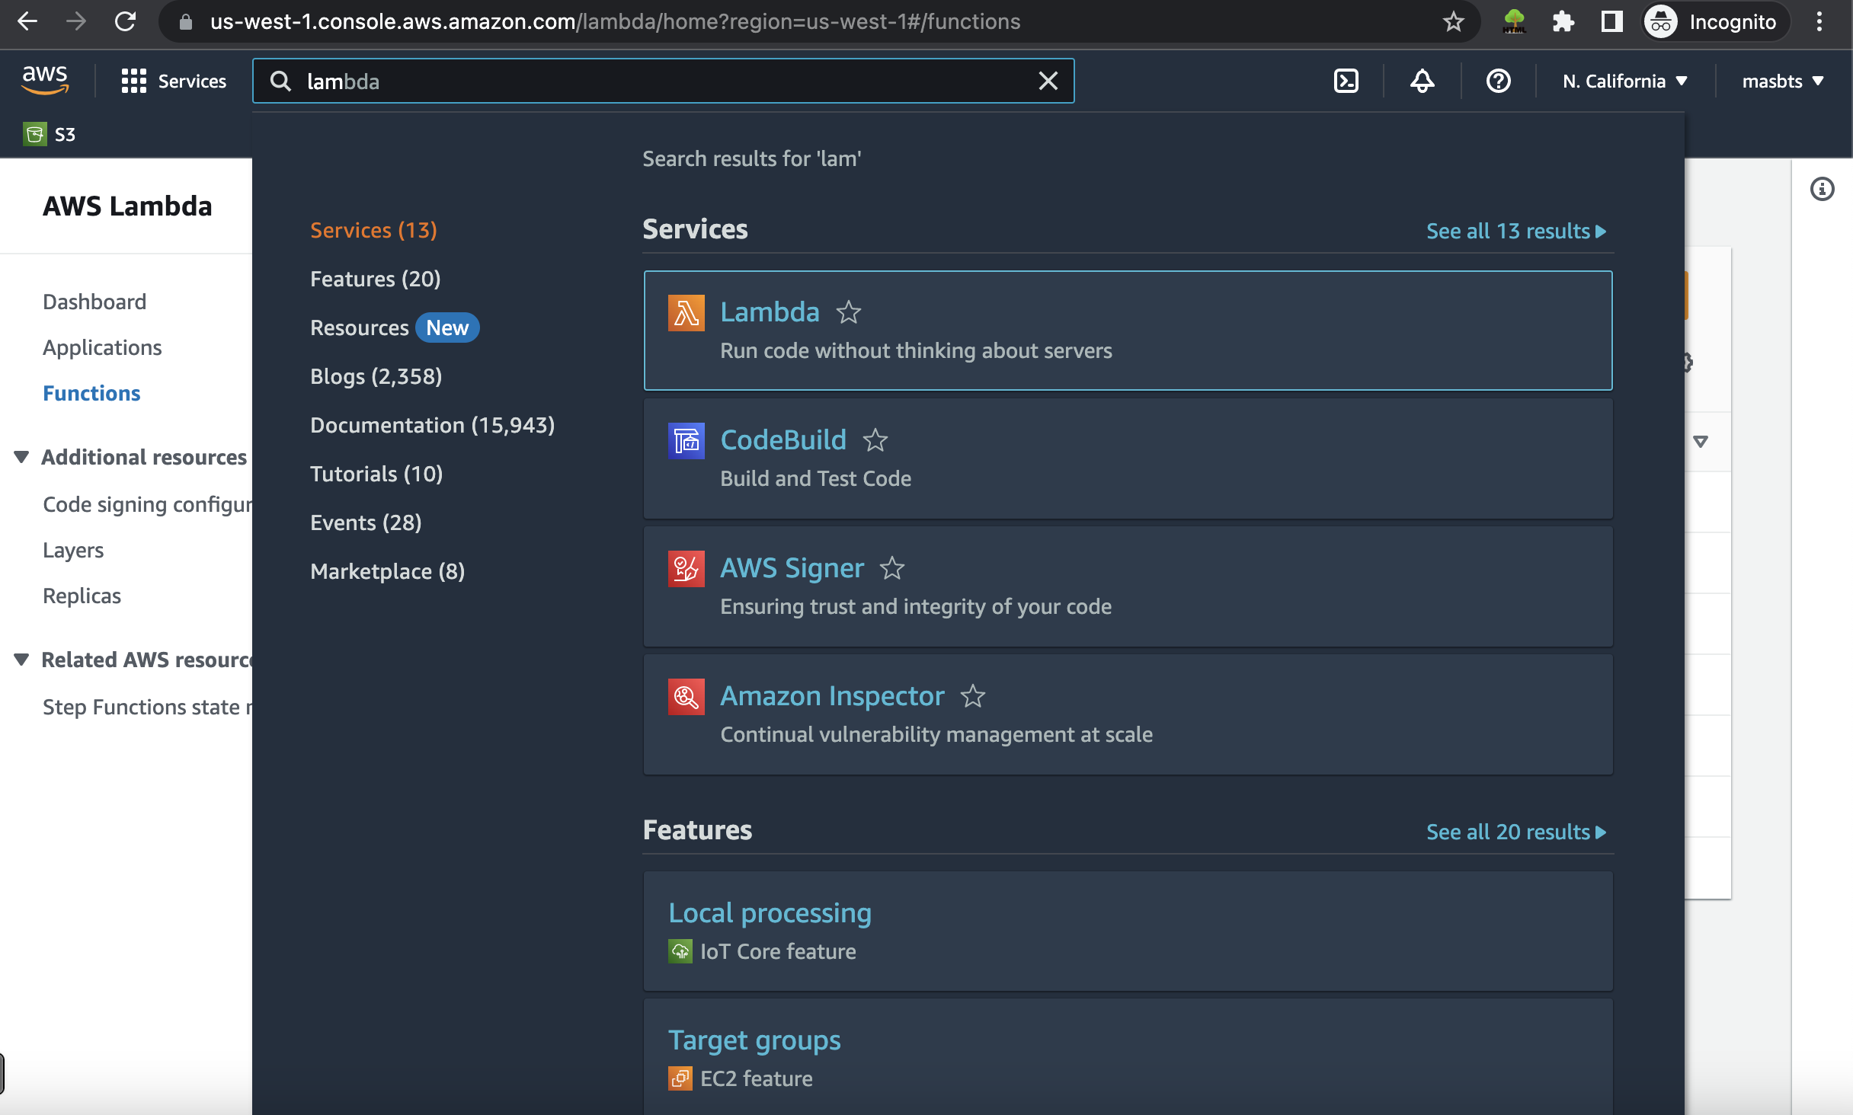

Create new Function:

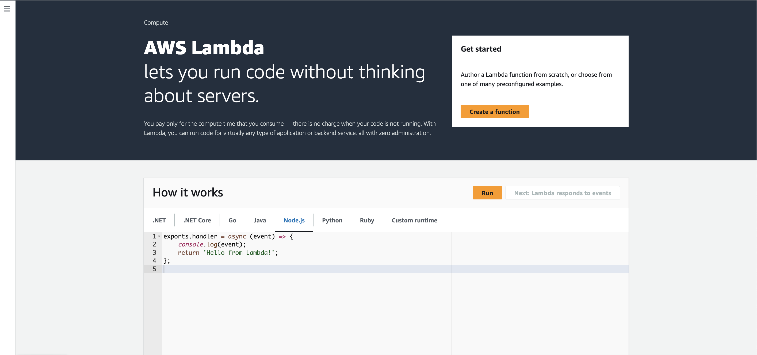

I will create mine called it “calc_average” and choose the latest version of python at this moment 3.10. then confirm creation.

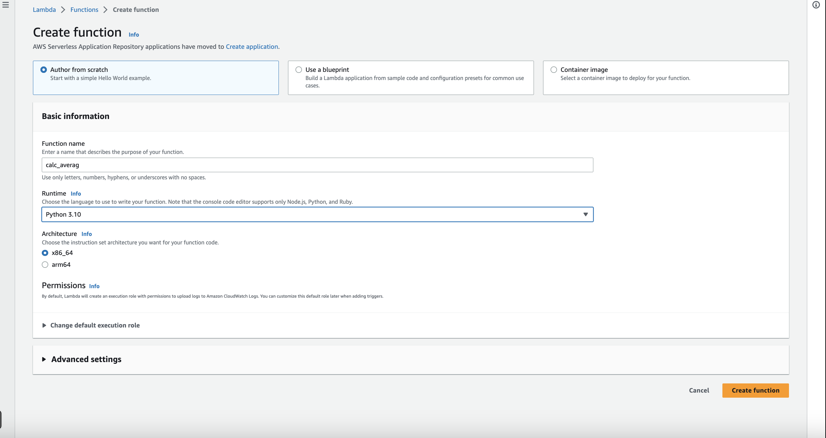

I will repeat the same step 3 times for every function we have (calc_middle) & (calc_power) & (calc_sqr)

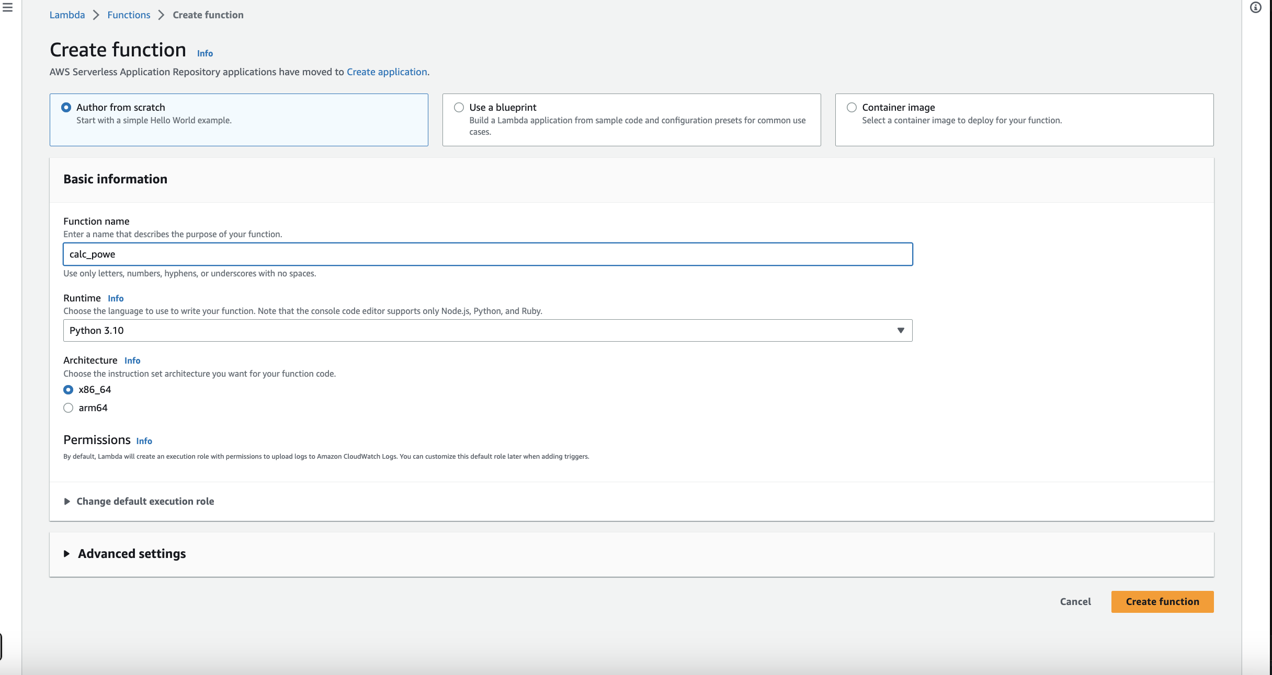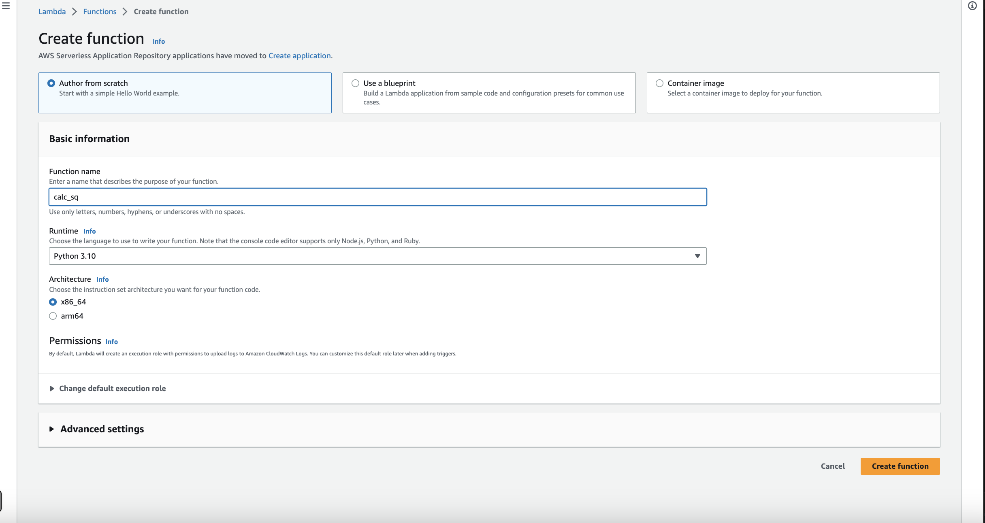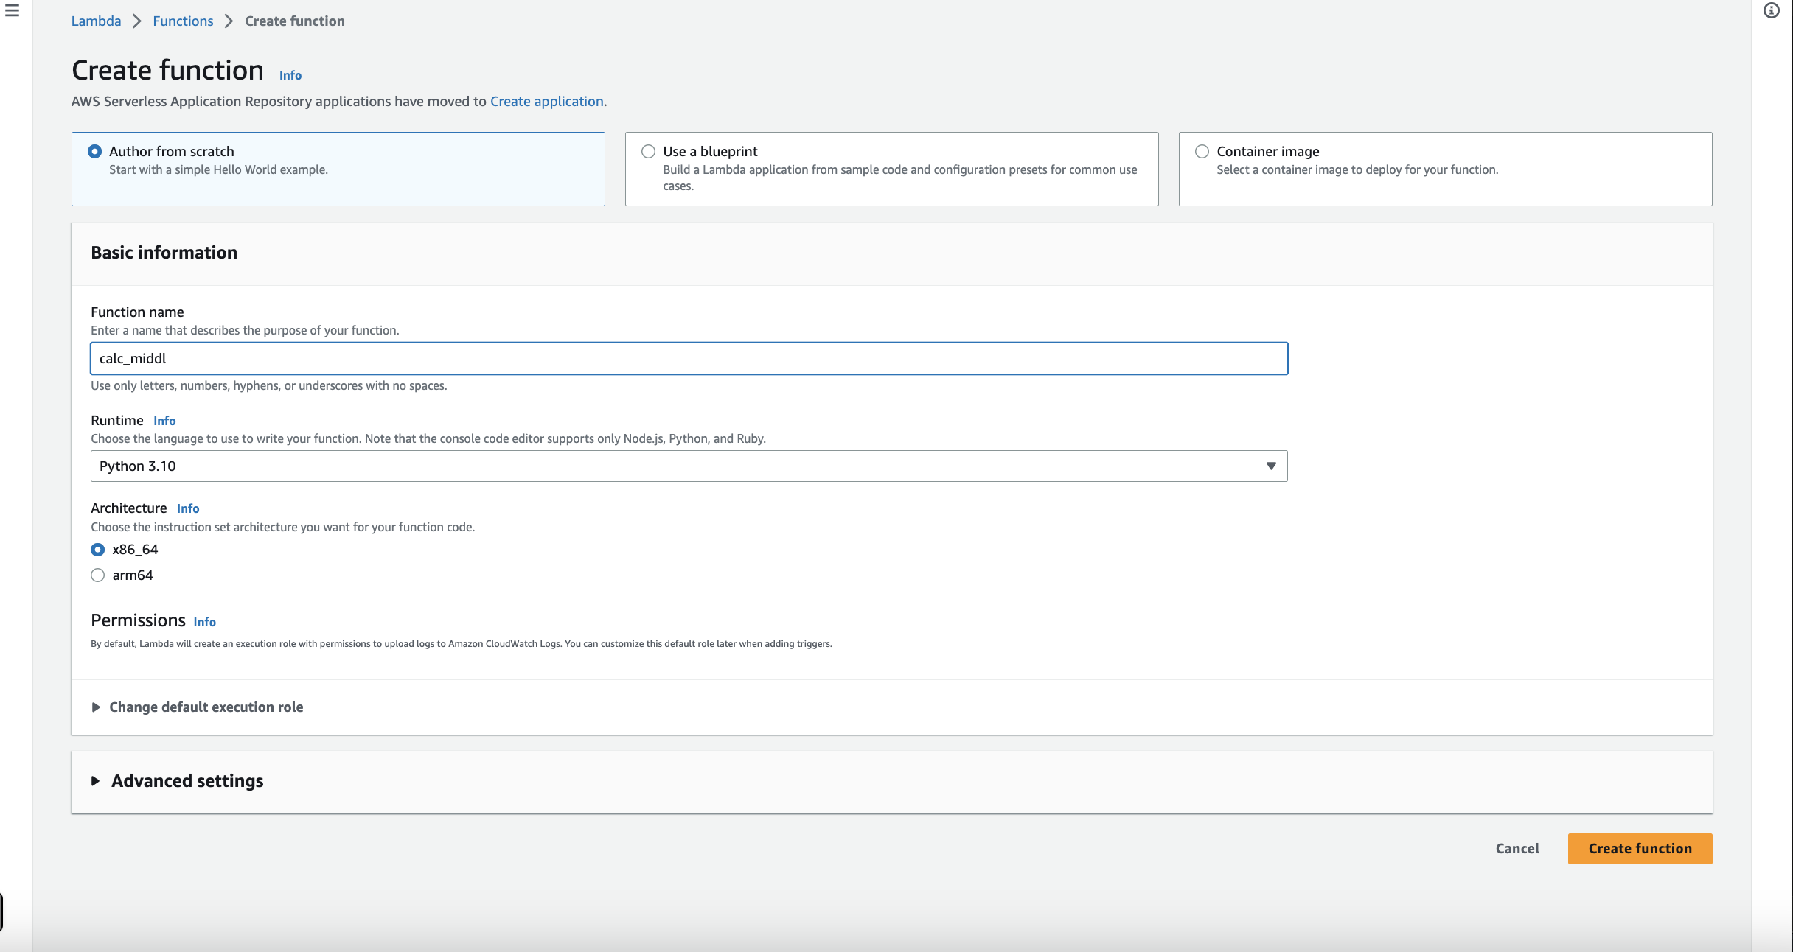

Now we are successfully having 4 functions.

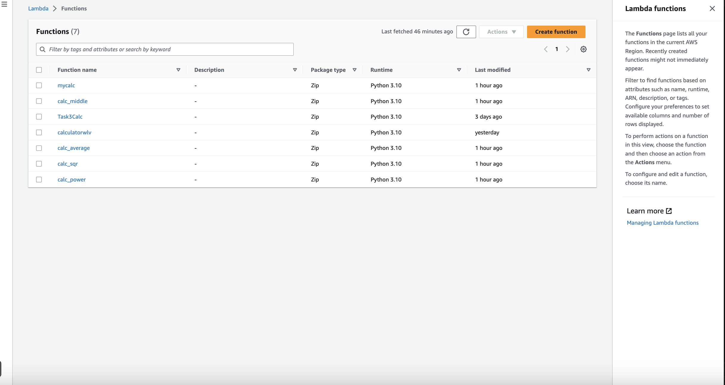

We will start modifying every function:

1. We will open calc_average function and scroll down to modify the code then copy the code from calc_average.py and paste it here and deploy.

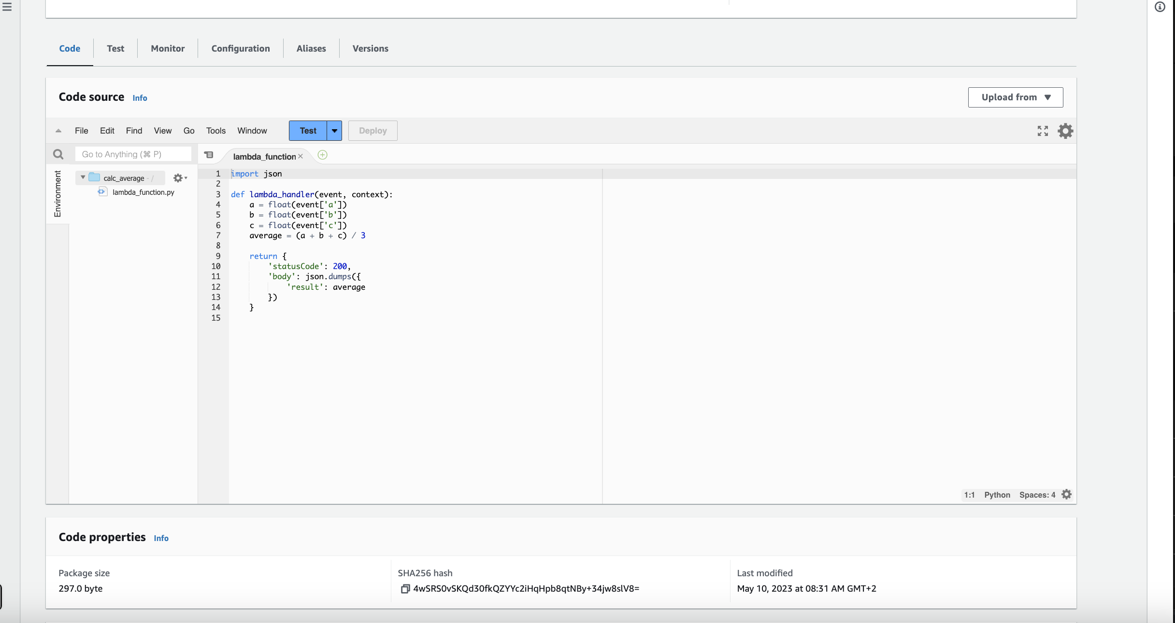

1. We will start creating a new test event and then name it, then copy the code from testerevent.json file and paste it below.

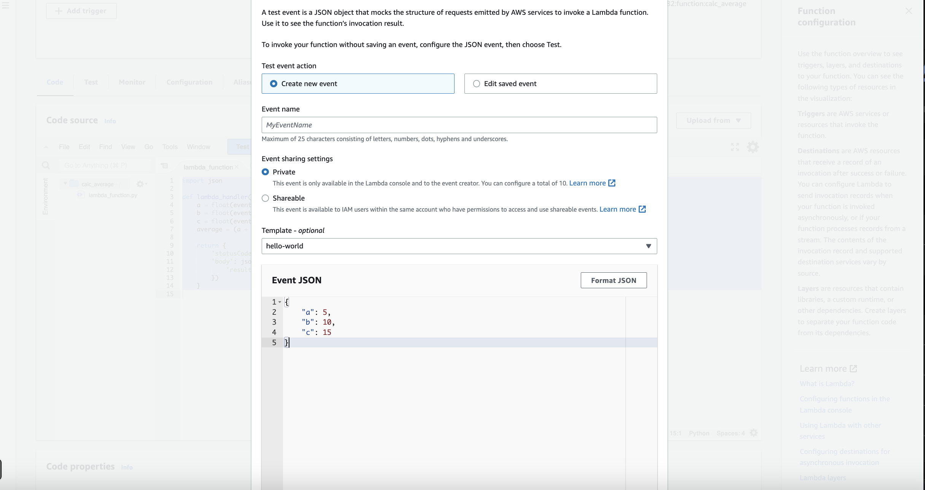

Save changes and then click on test.

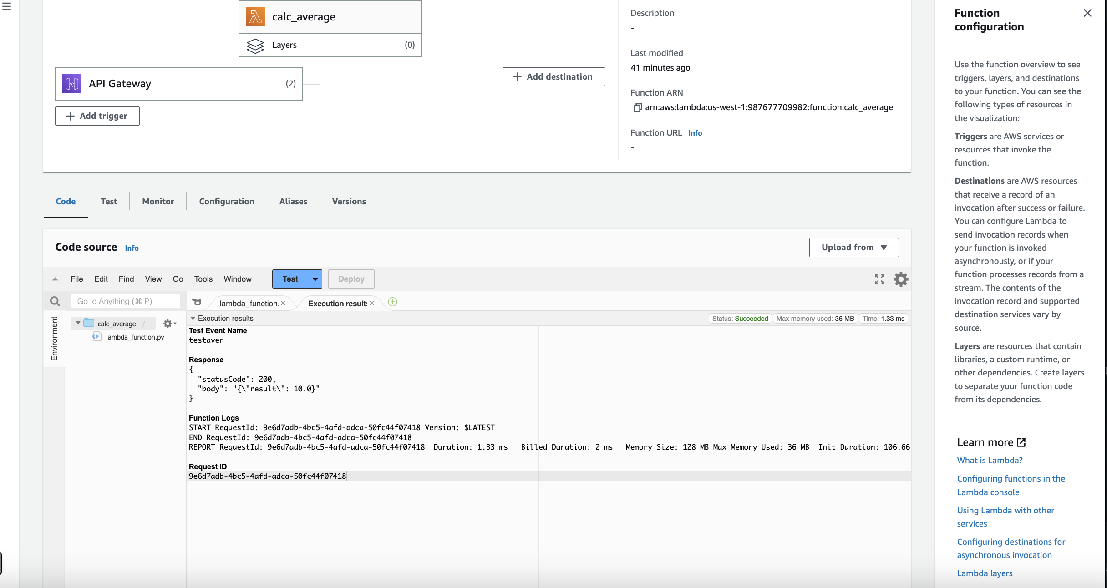

As we can see the expected output.

1. We will repeat this step again with every other function just modifying with relevant code.

### calc_middle:

1. Open calc_middle.py code and put it then deploy

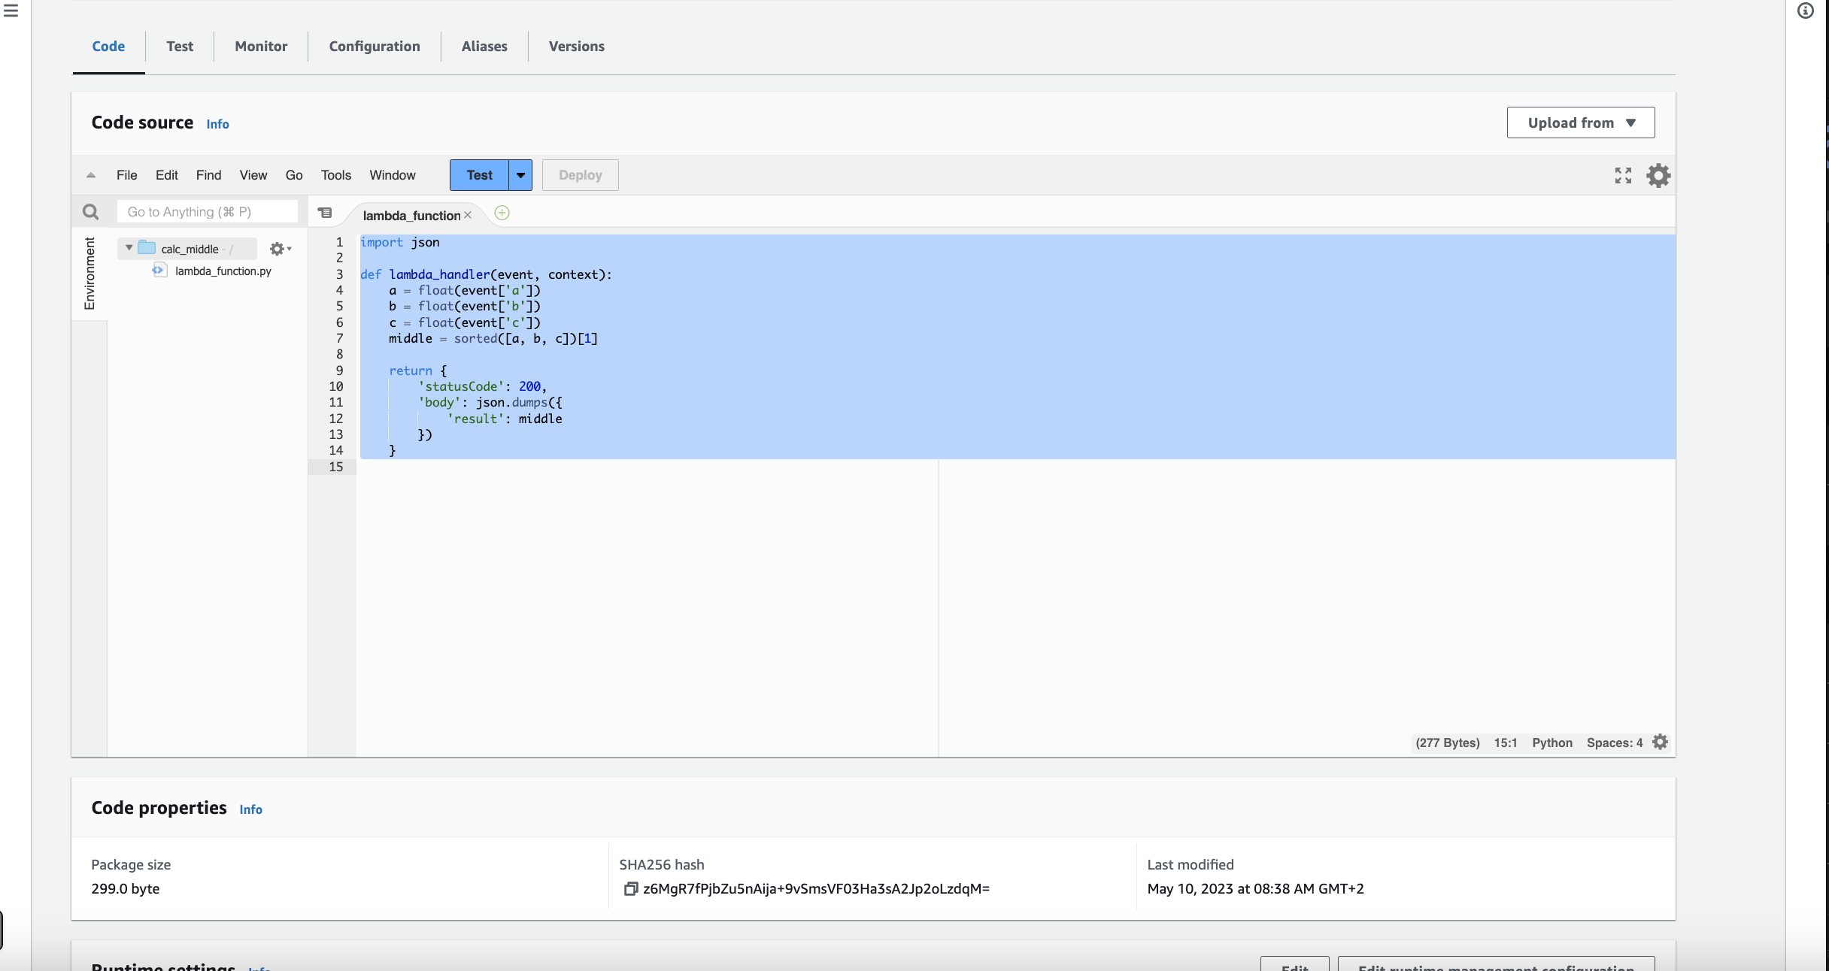

1. Doing new test event and put same values from calc_average

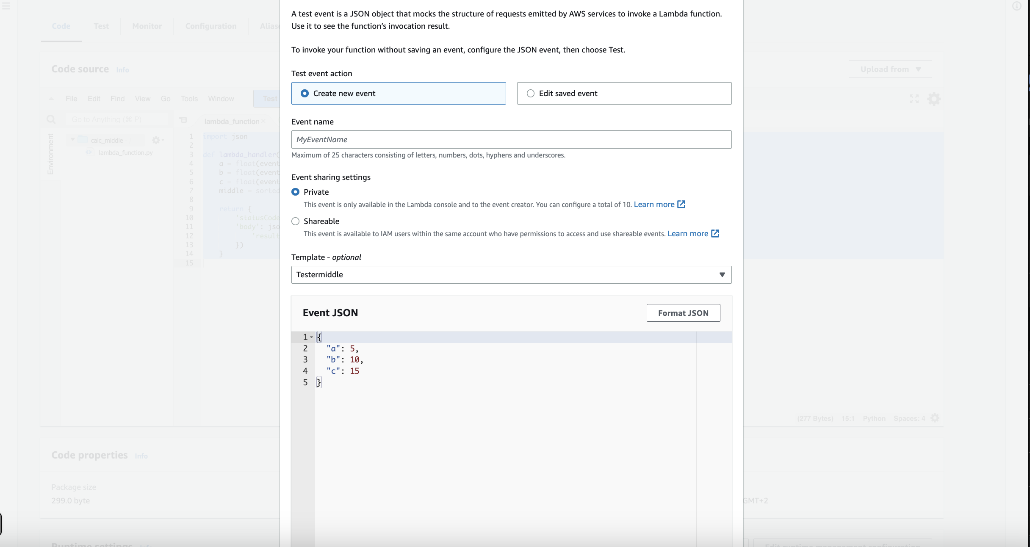

1. Result of testing

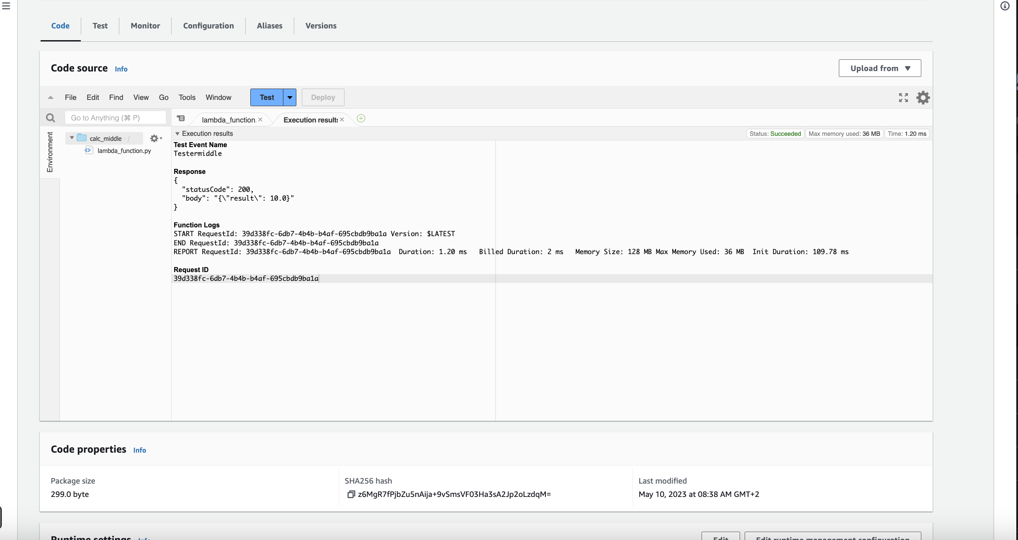

Open calc_power function

1. copy the code from [calc_power](https://us-west-1.console.aws.amazon.com/lambda/home?region=us-west-1#/functions/calc_power) and paste it then deploy.

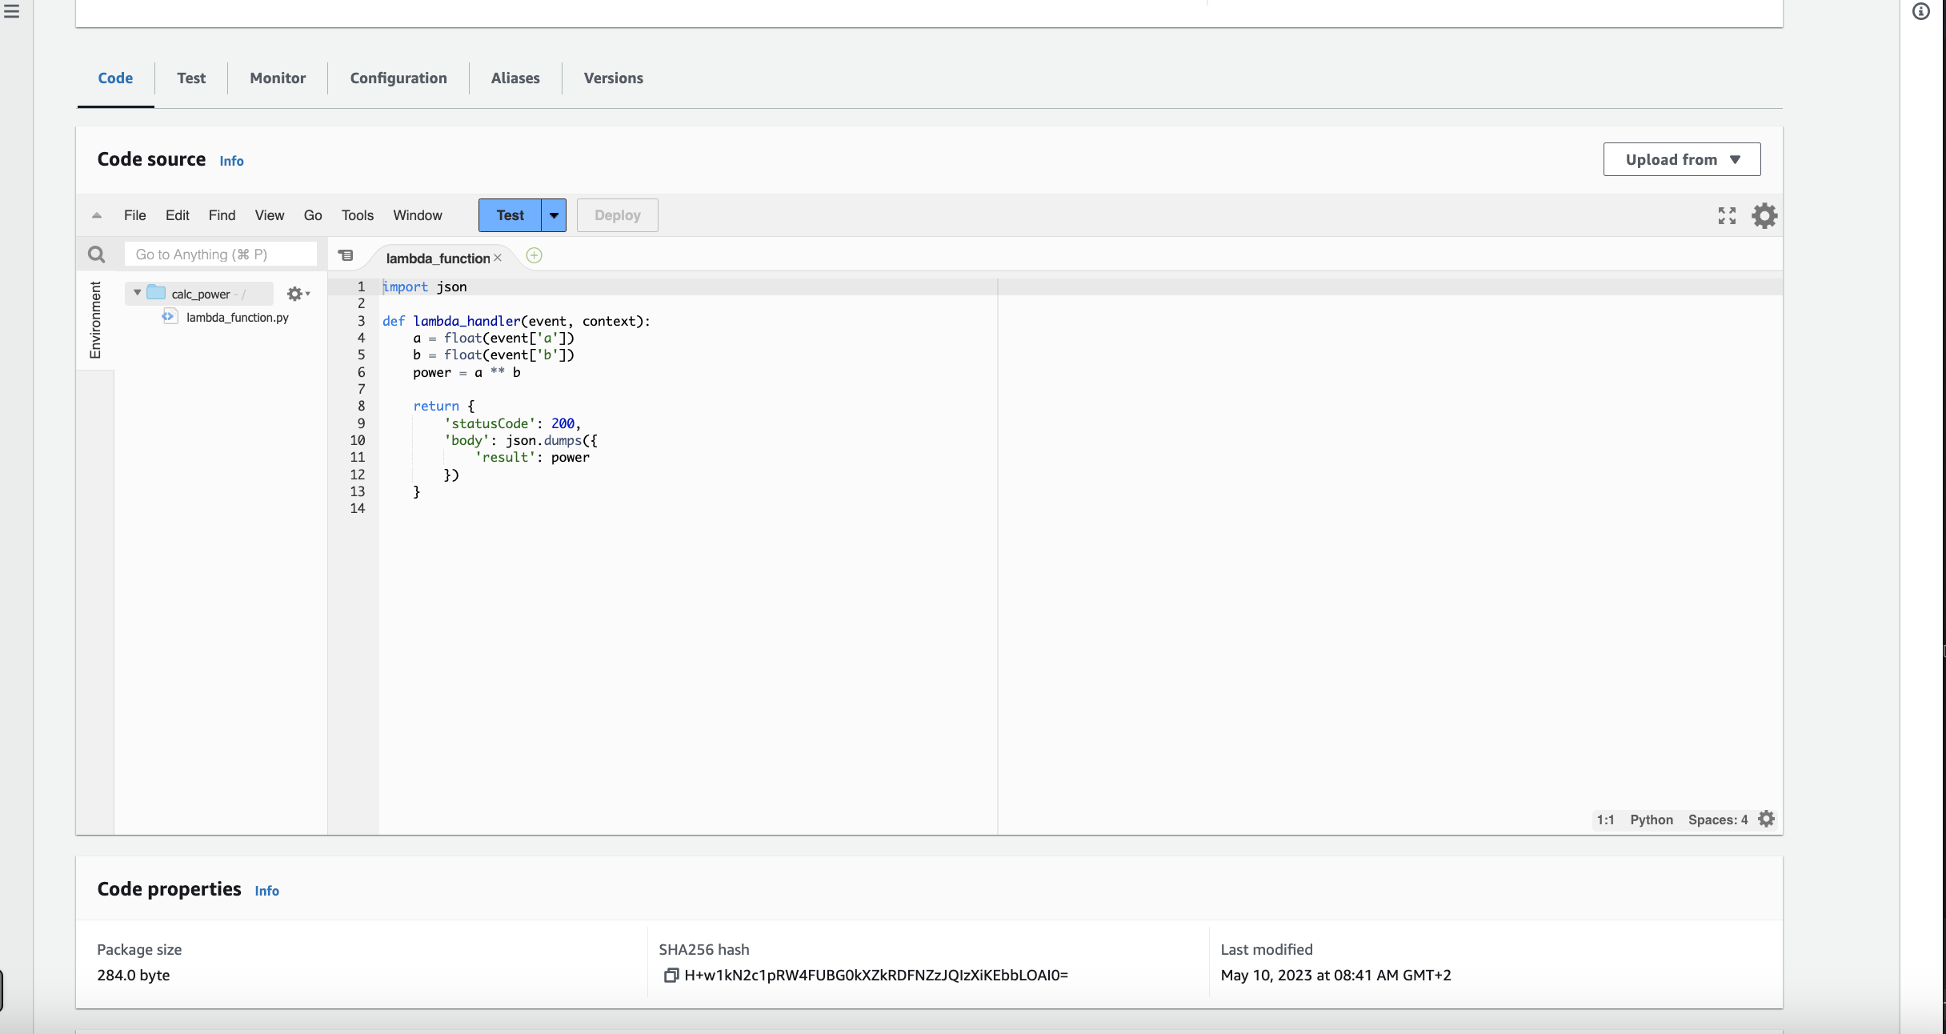

1. Create new test event and input same value as well

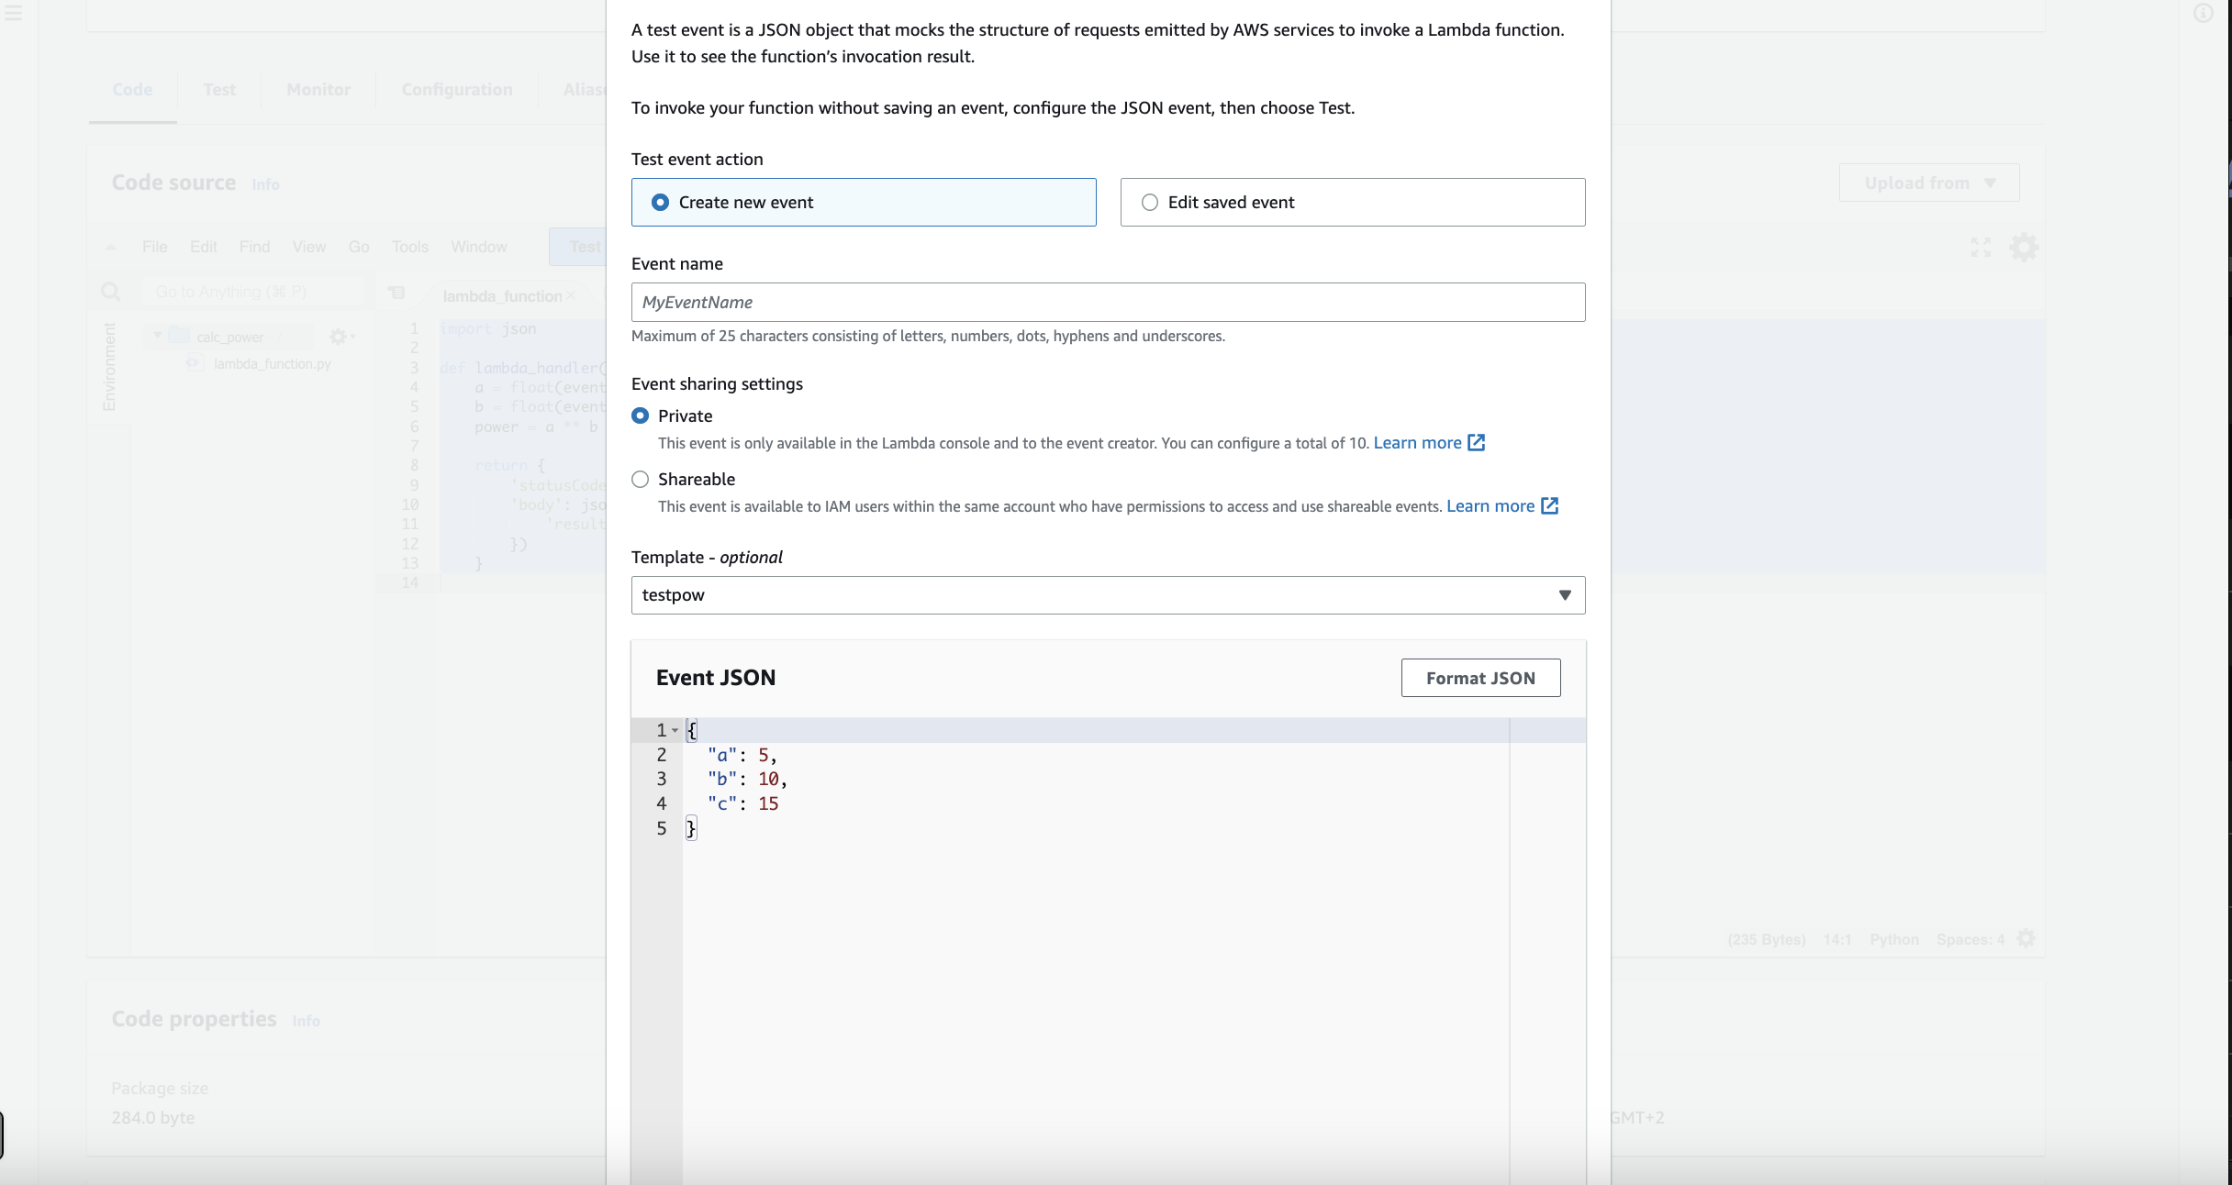

1. Result of testing:

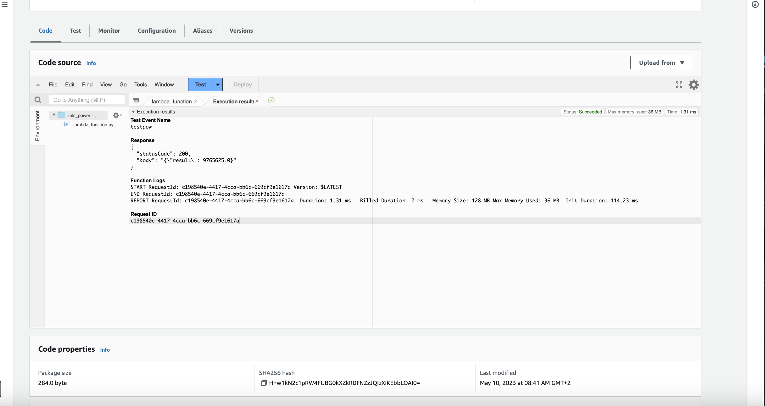

### Open calc_sqr function

### Copy the code from calc_sqr.py file and paste it then deploy

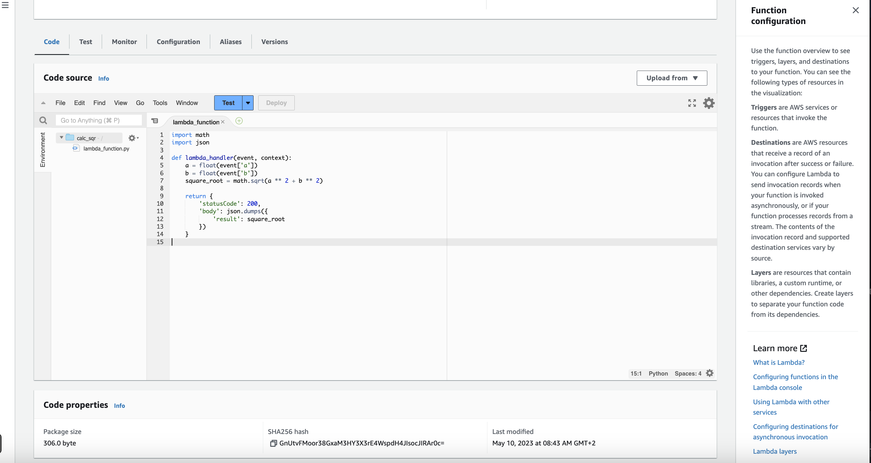

1. Create new test event and add the same value we did before

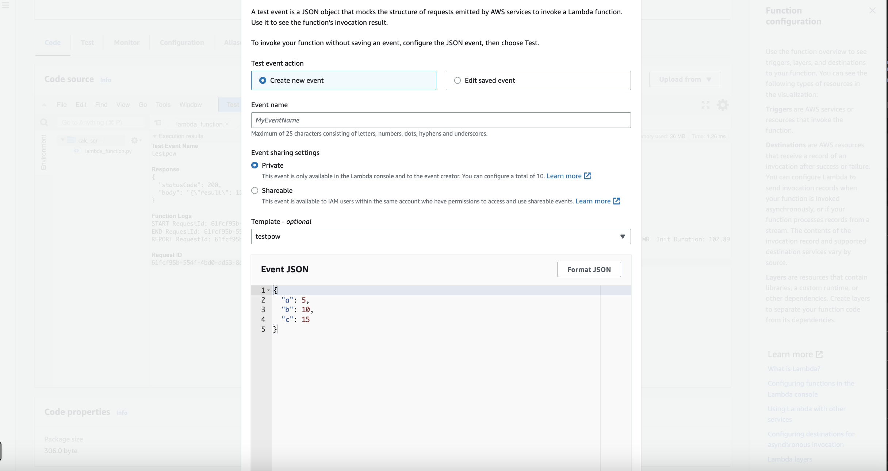

1. Click on test button, for the result of testing:

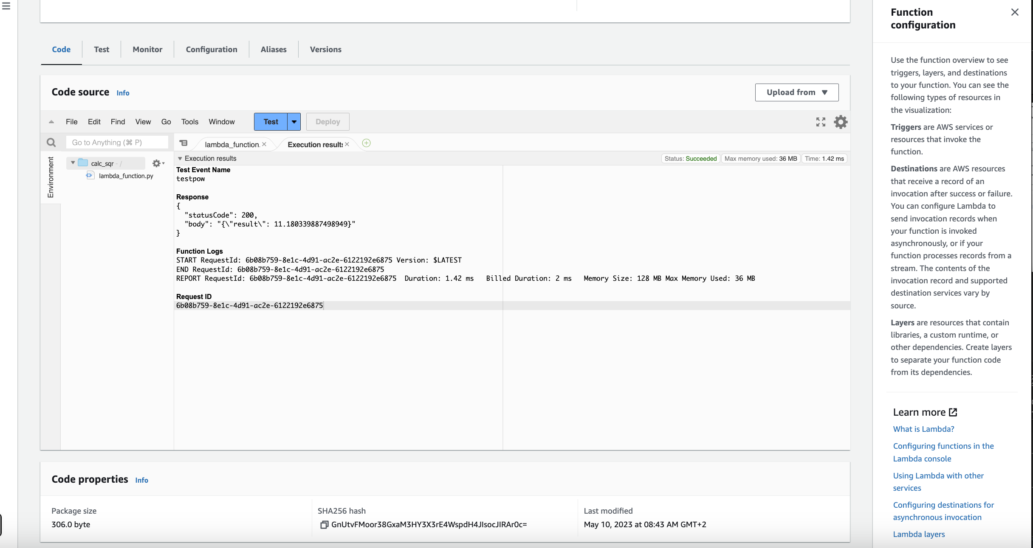

Now we have 4 functions working as expected, let us create the API.

From research bar again look for API this time.

1. Scroll down till see REST API and start building.

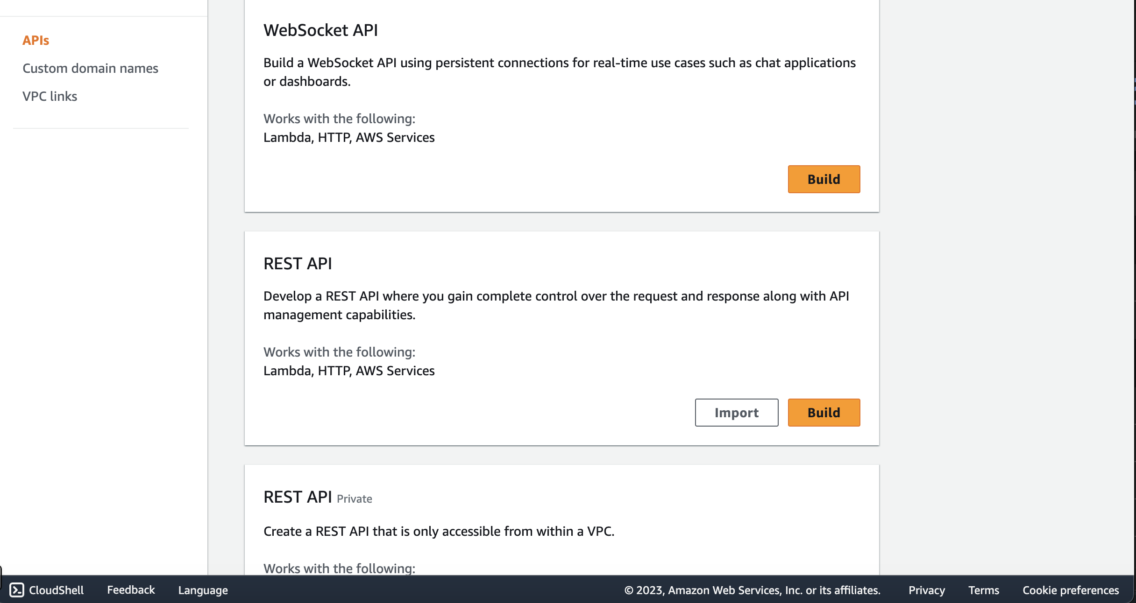

Now we will choose to create a new API and enter the name of it then hit create API to confirm it.

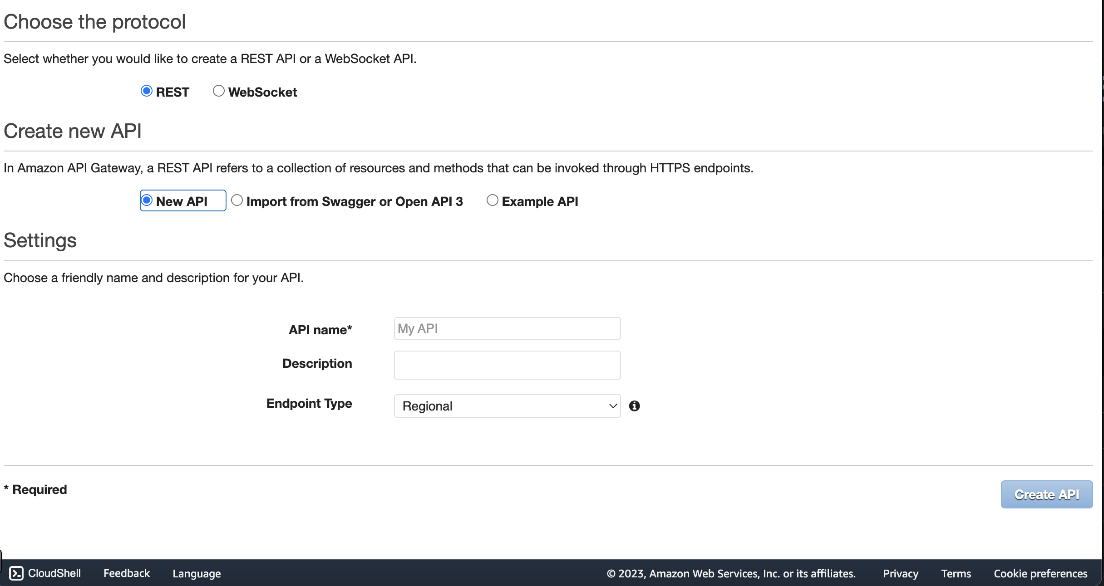

I choose the name of [Mycalc](https://us-west-1.console.aws.amazon.com/apigateway/home?region=us-west-1#/apis/jc0ps6oktk/resources)

From the Actions we will choose create resource



Then create 4 resources for each function I will name them with the same approach way of my functions.

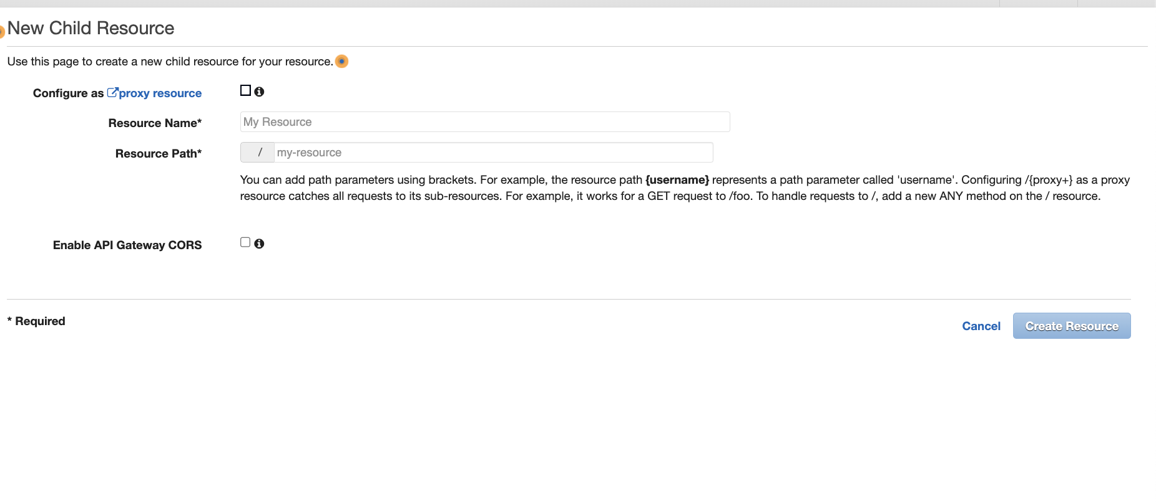

Result of resources

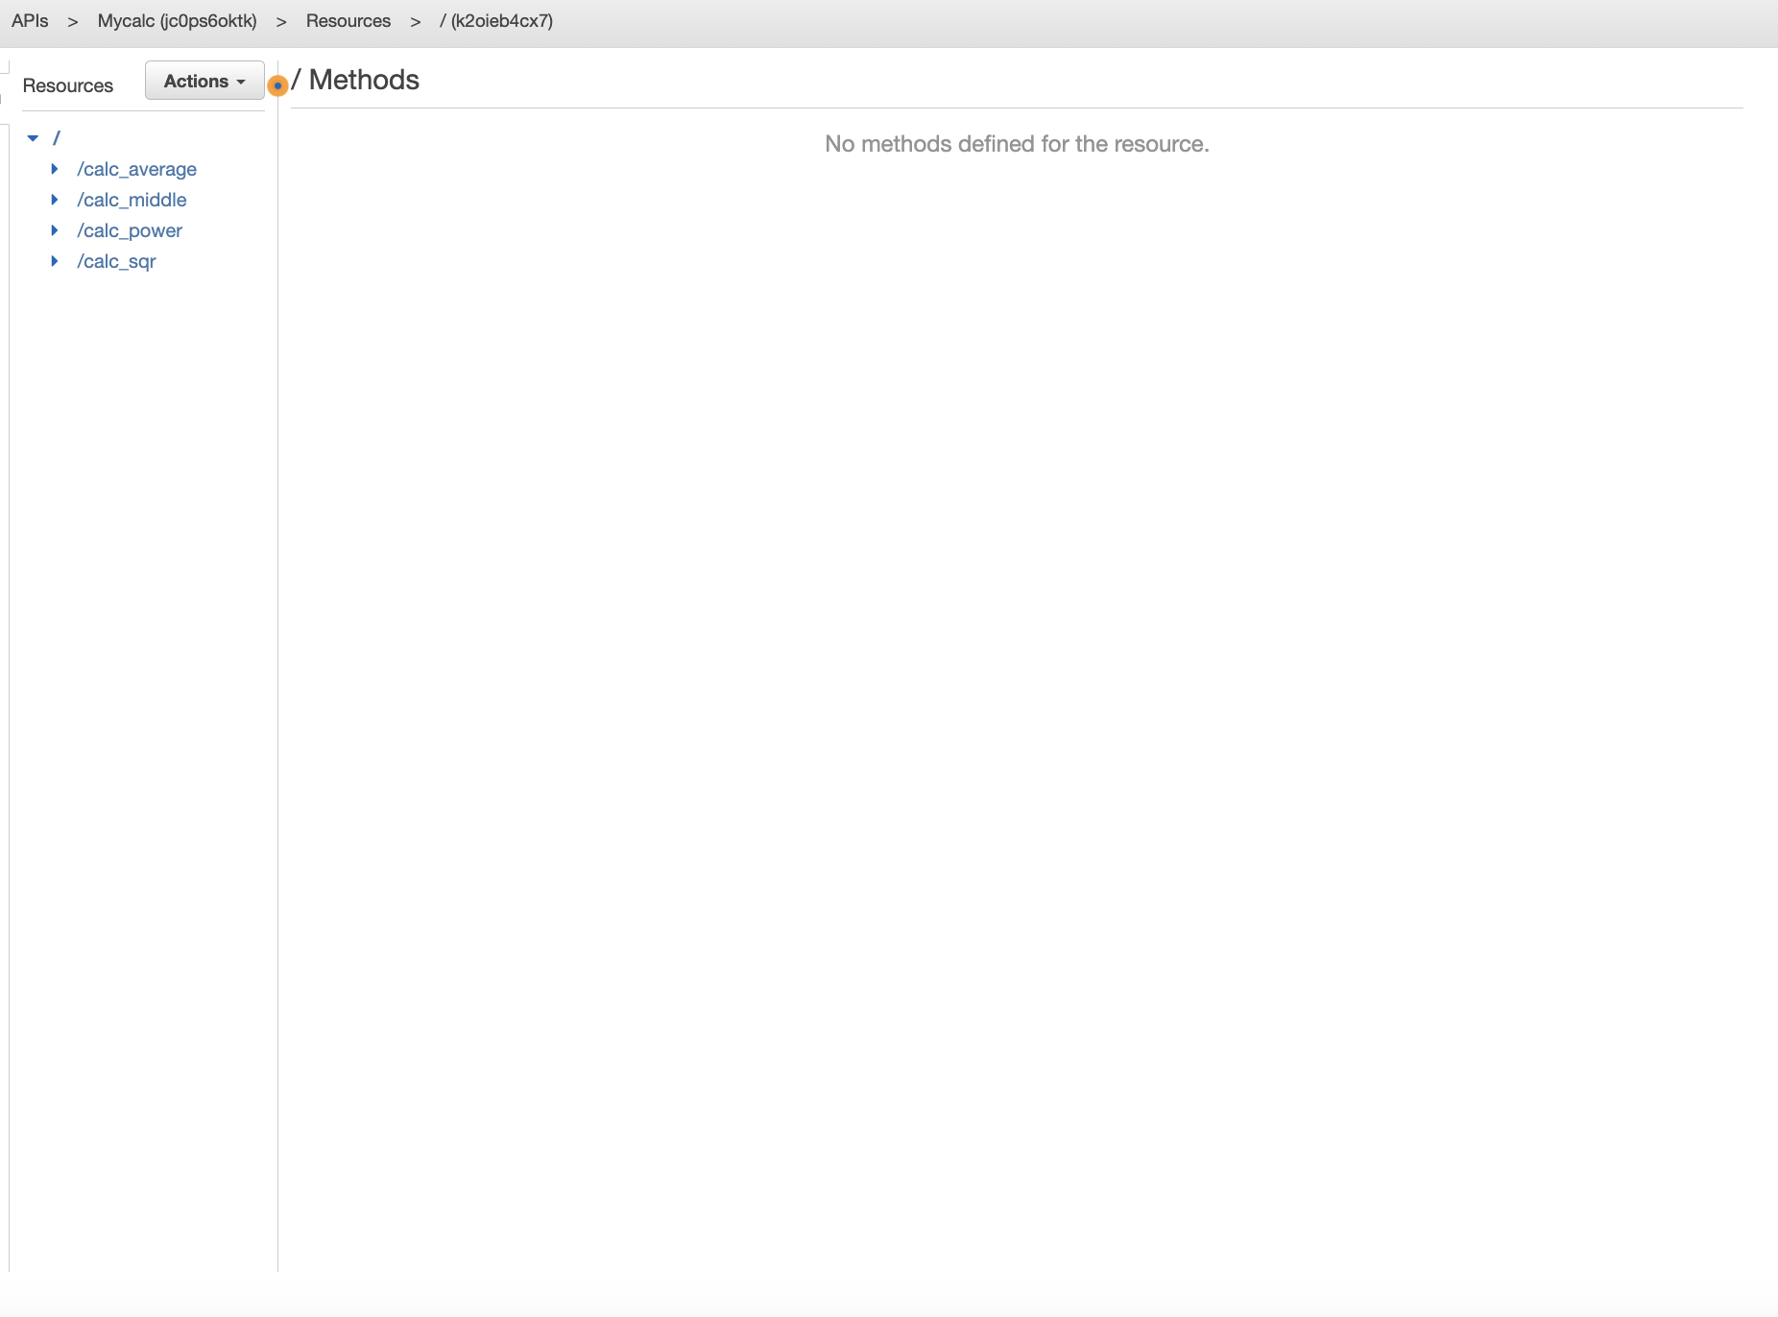

Now I will customize each resource through click on actions and choose Methods then “GET”

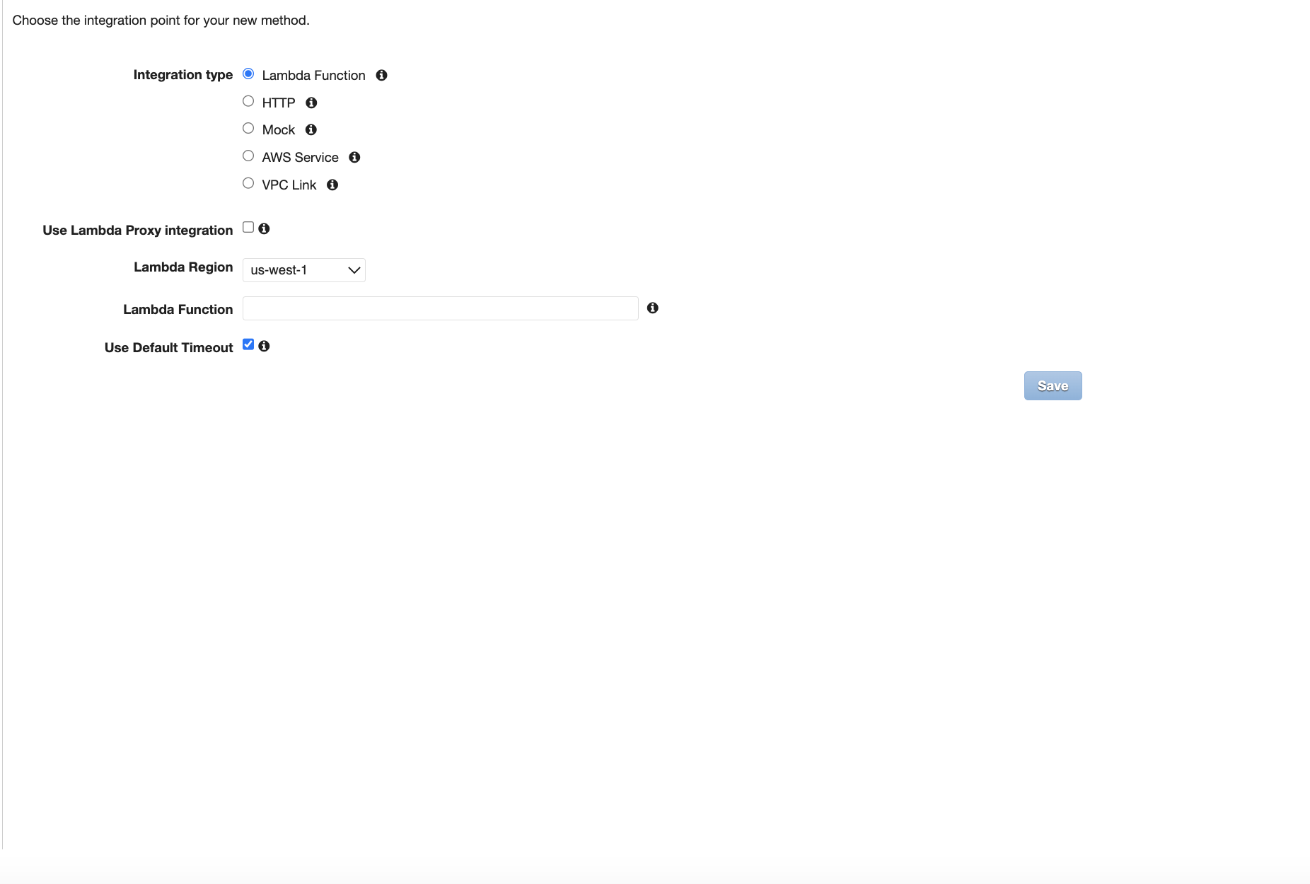

In the section of Lambda function, we need to enter the exact name of the function for this resource

I will repeat the steps 4 times.

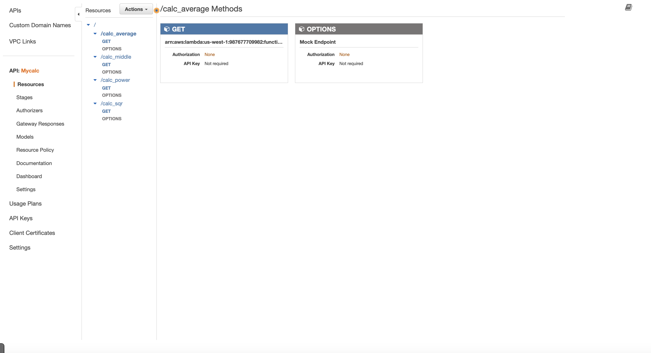

Now we will customize every method by going to “[Integration Request](https://us-west-1.console.aws.amazon.com/apigateway/home?region=us-west-1#)"

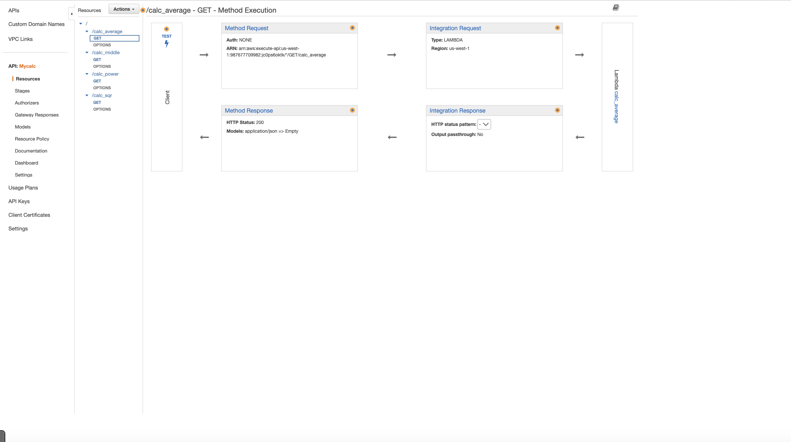

Click on Mapping template and then add mapping template choose type “**application/json”**

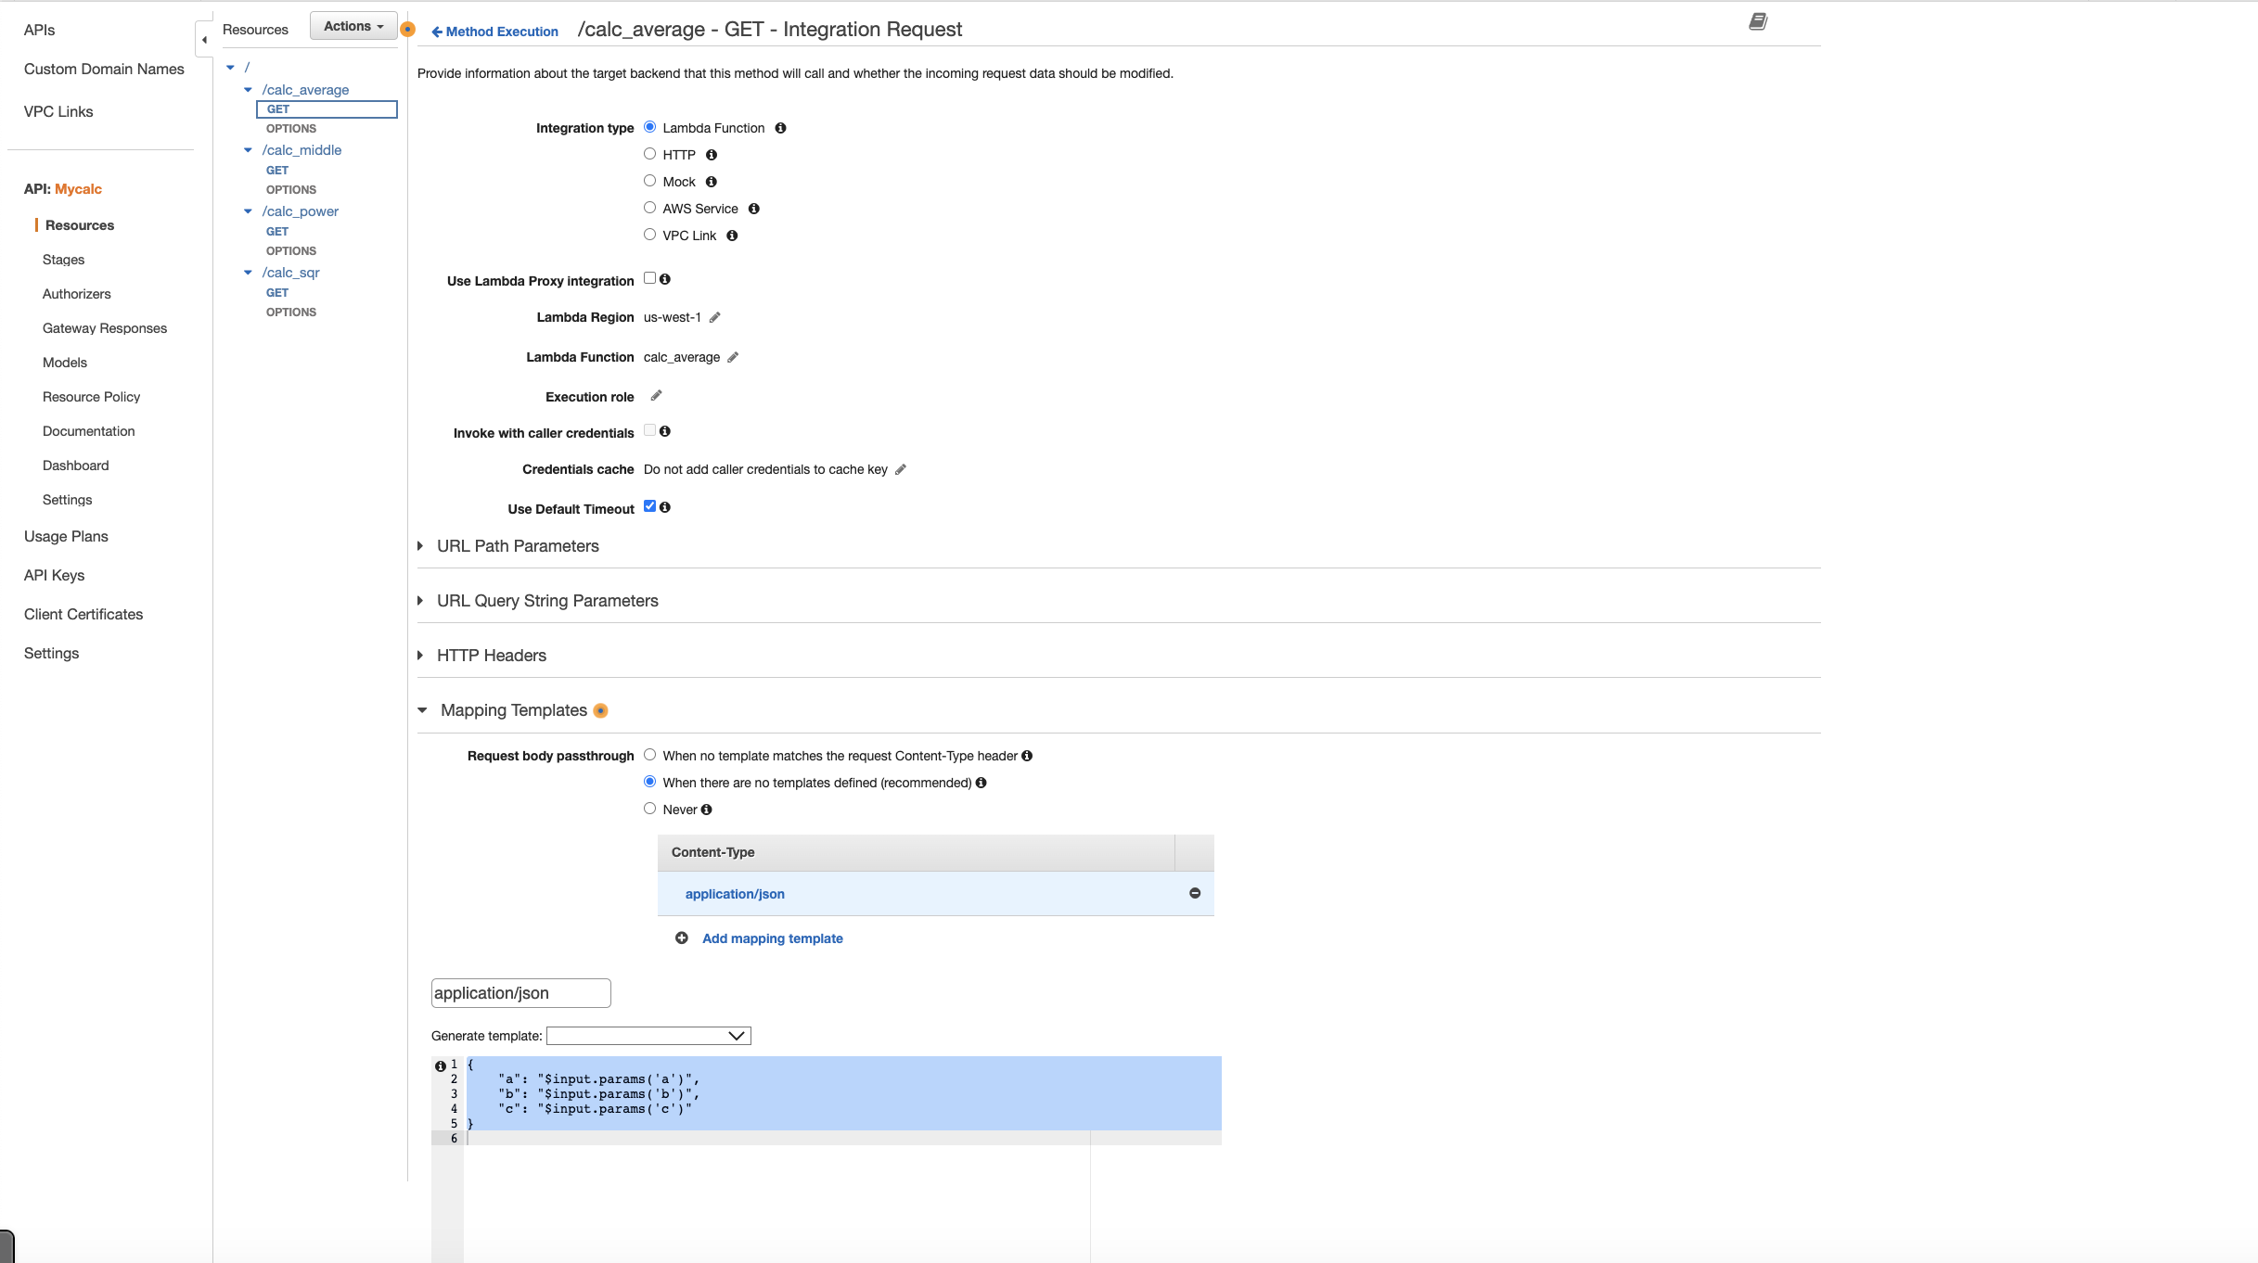

And add the mapping filter from the application/json.json file

Then save changes.

We will repeat the same step for the rest of the other methods.

Results:

## calc_middle

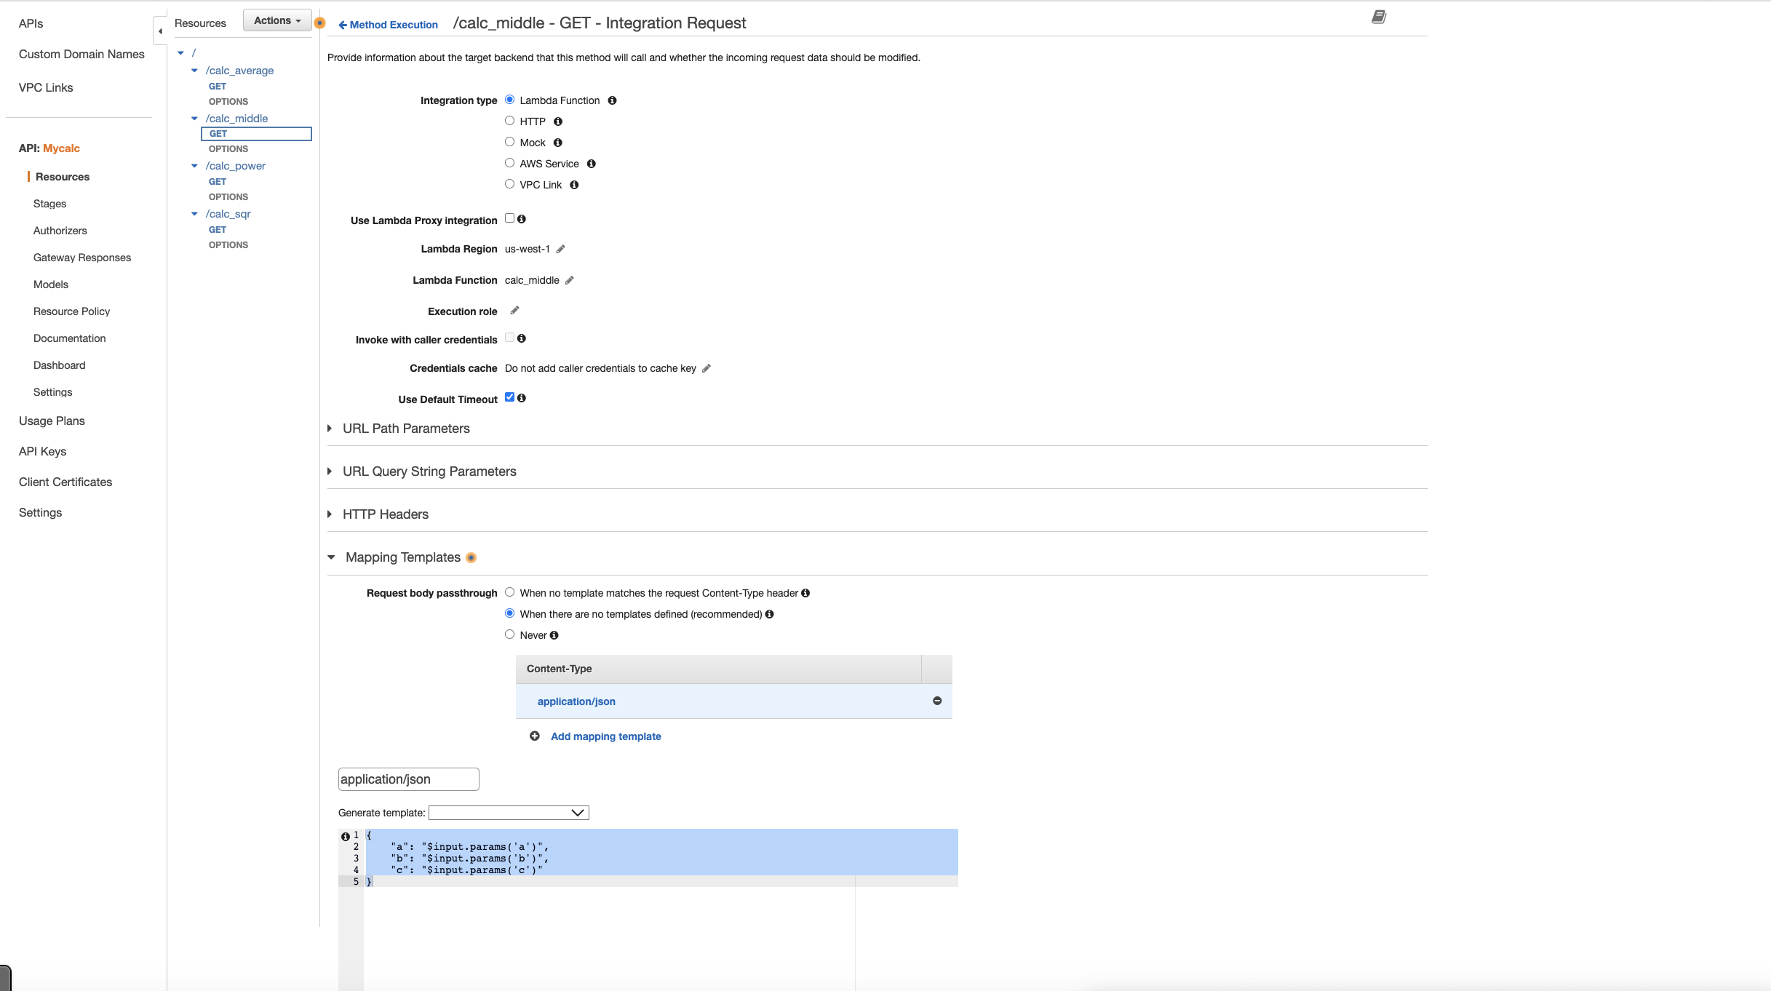

## calc_power

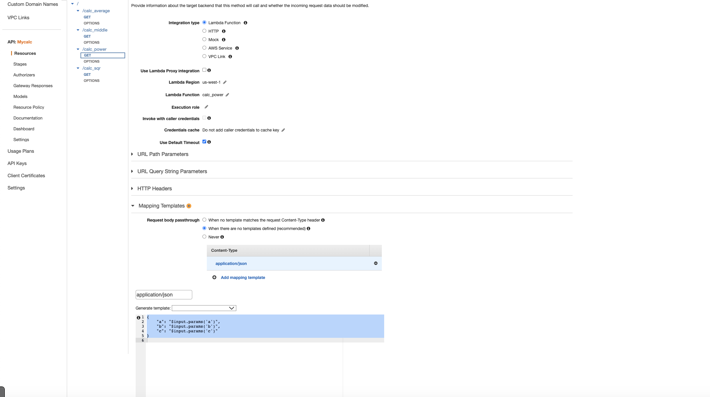

Calc_sqr

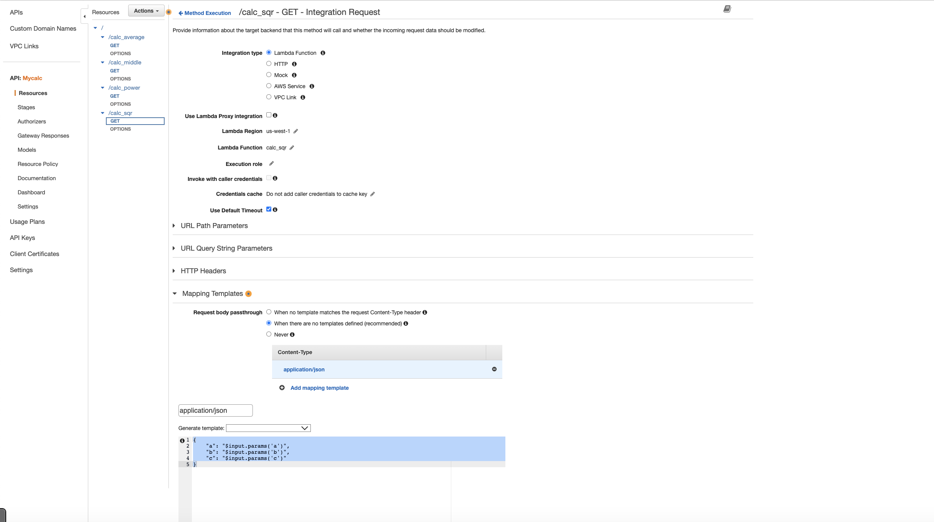

Enable CORS:

Now we will enable CORS for every resource.

Through actions will choose from drop menu “Enable CORS ”

## Enable CORS calc_average

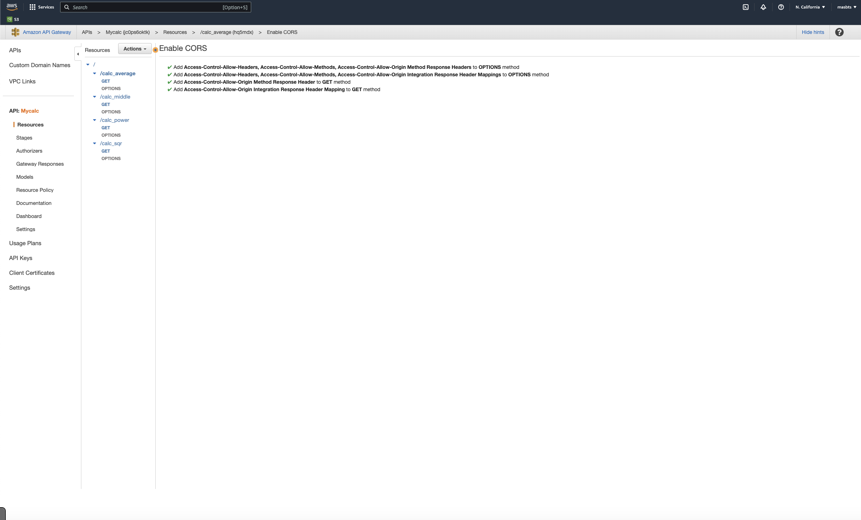

Enable CORS calc_middle

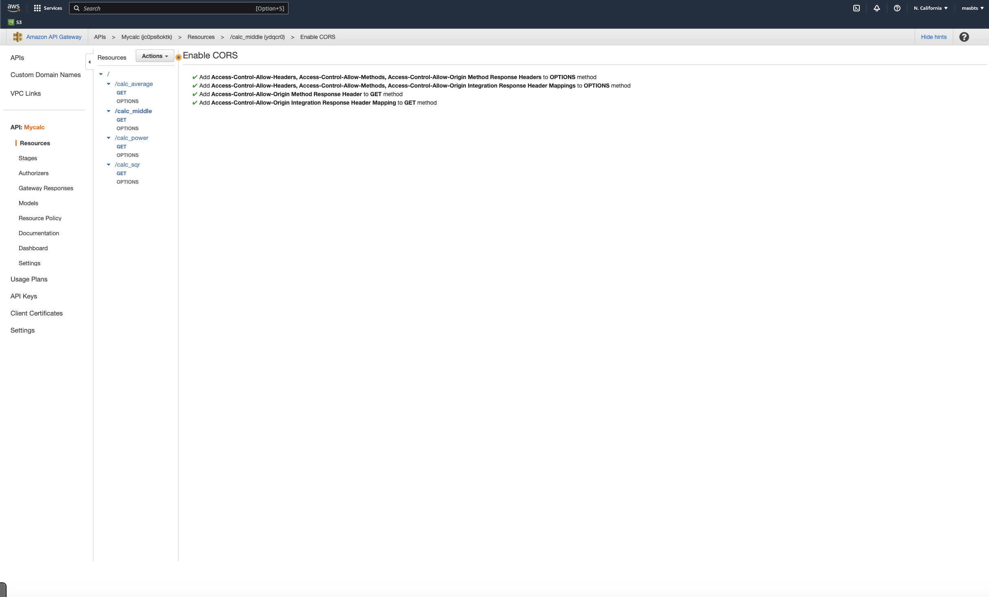

Enable CORS calc_power

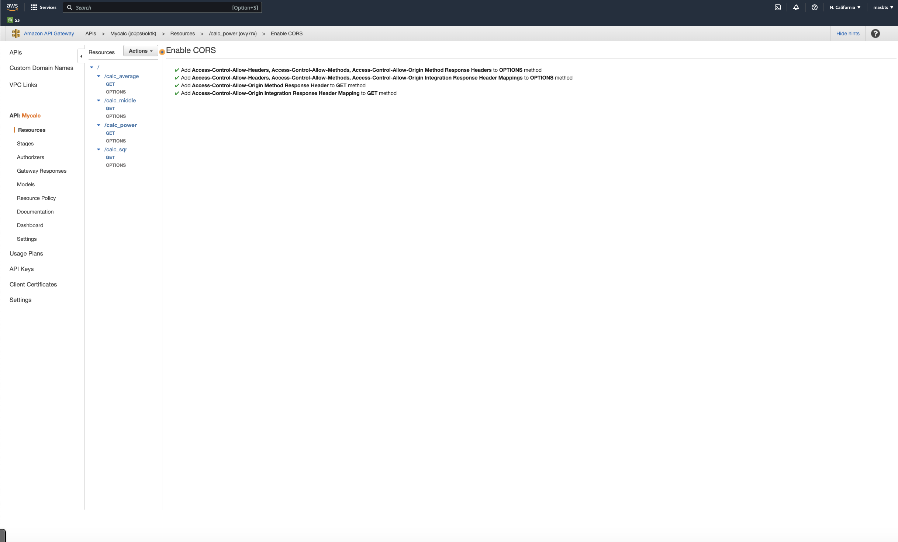

Enable CORS calc_sqr

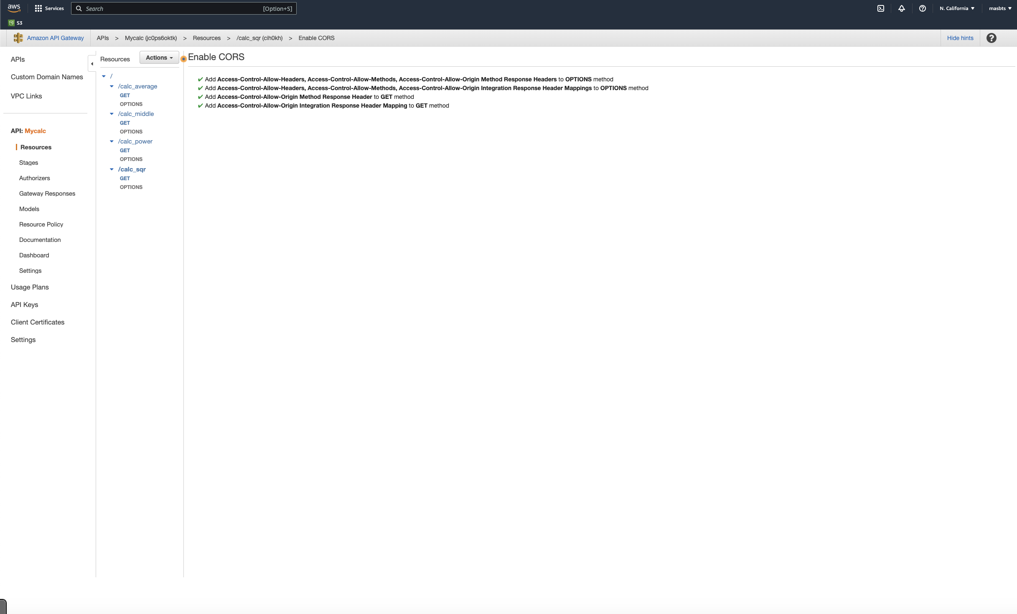

Now we will be deployed to test REST API

From action again select Deploy API name stage I.e prod

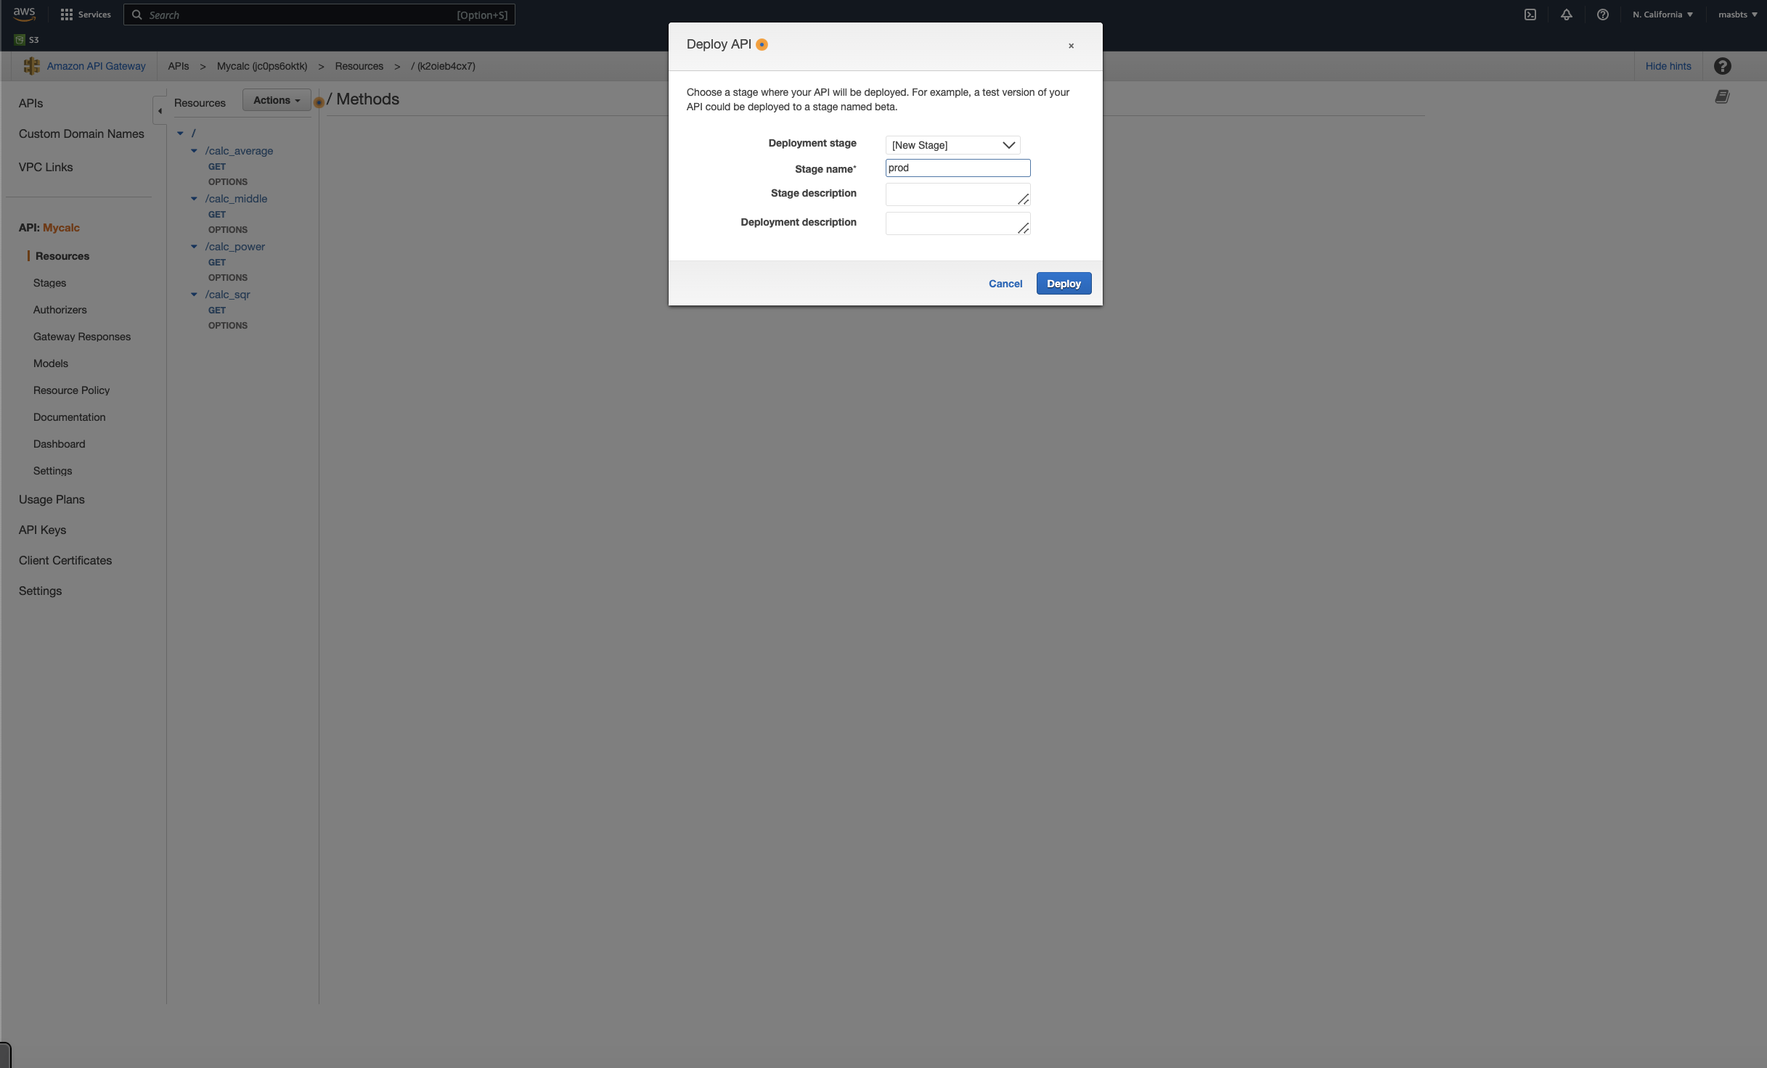

Now we get Invoke URL: <https://jc0ps6oktk.execute-api.us-west-1.amazonaws.com/prod>

Adding after prod the function name let’s try to start testing through

?a=[Value]=[Num]&Value]=[Num]&Value]=[Num]

Let us test REST API for every function:

Results:

calc_average

<https://jc0ps6oktk.execute-api.us-west-1.amazonaws.com/prod/calc_average?a=5&b=10&c=15>

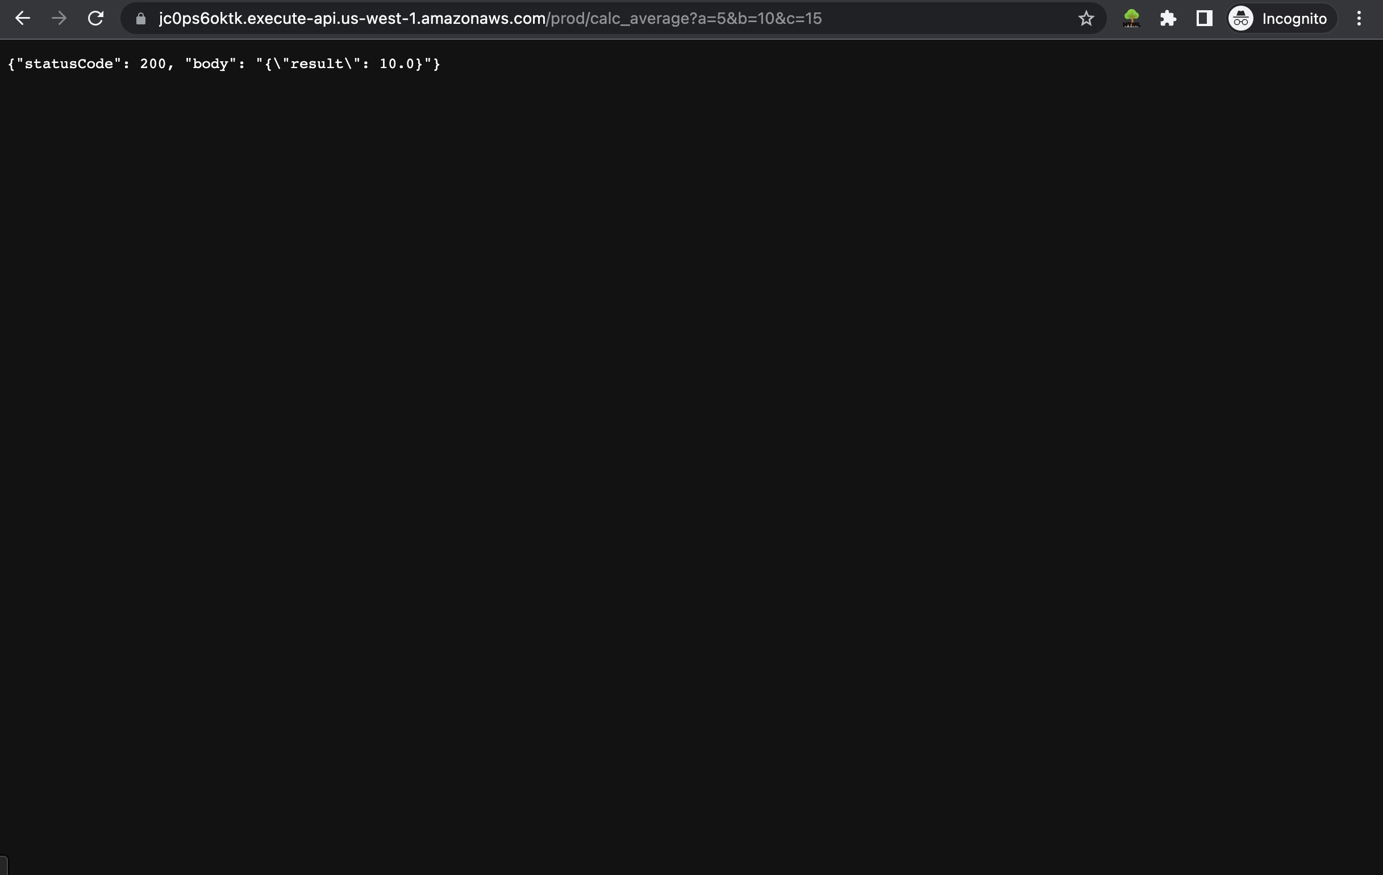

Calc_middle

<https://jc0ps6oktk.execute-api.us-west-1.amazonaws.com/prod/calc_middle?a=5&b=10&c=15>

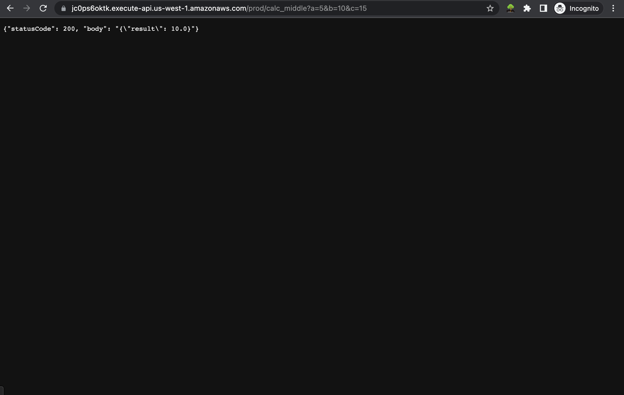

Calc_power

<https://jc0ps6oktk.execute-api.us-west-1.amazonaws.com/prod/calc_power?a=5&b=10&c=15>

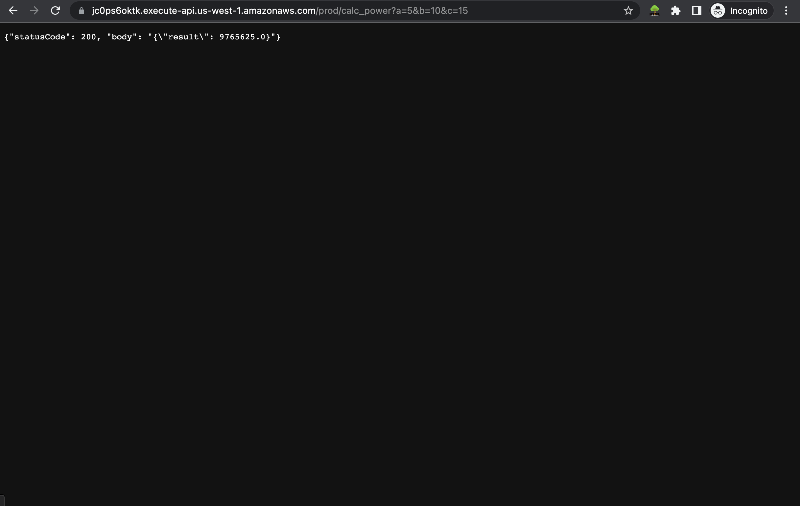

Calc_sqr

<https://jc0ps6oktk.execute-api.us-west-1.amazonaws.com/prod/calc_sqr?a=5&b=10&c=15>

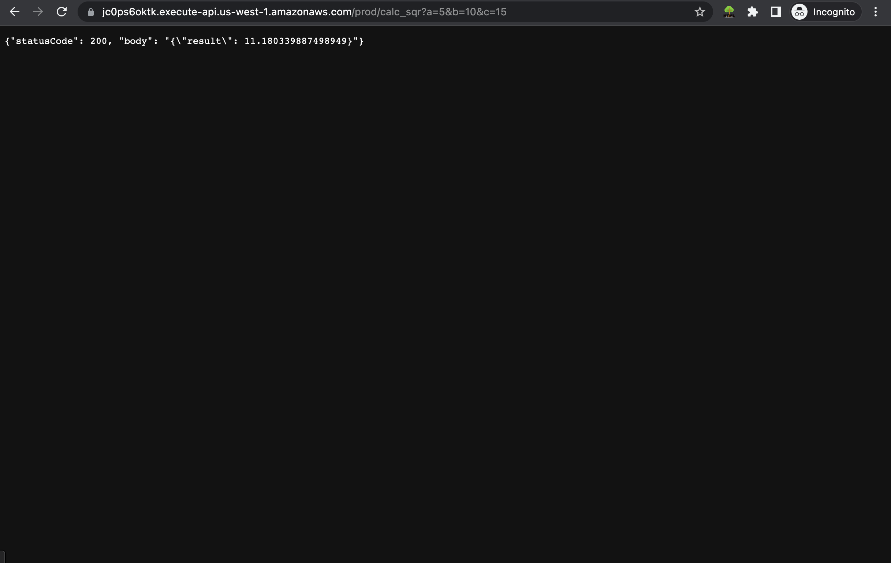

Creating bucket S3 to host the website

Start by creating new bucket

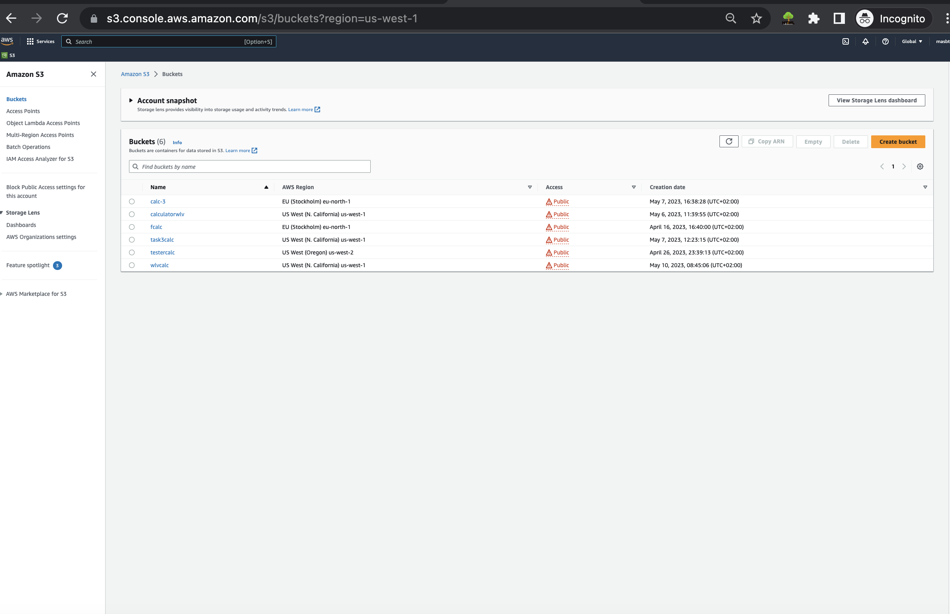

Choose Bucket name and untick of option for block public access setting then create bucket.

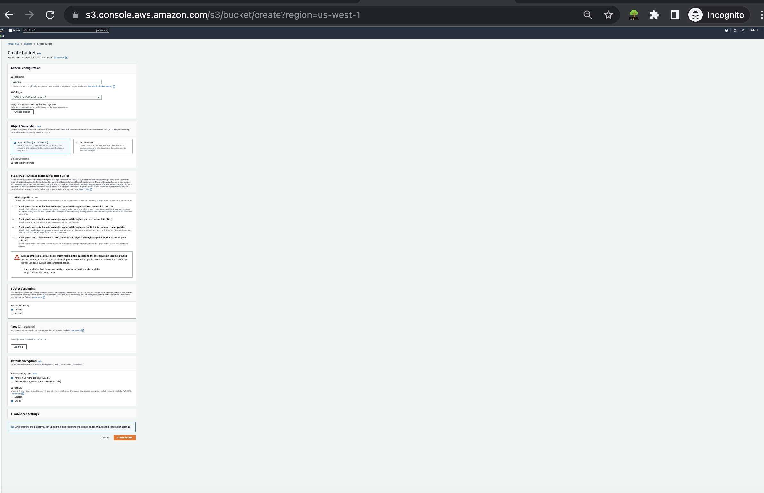

Going to permission then modify ARN with ours

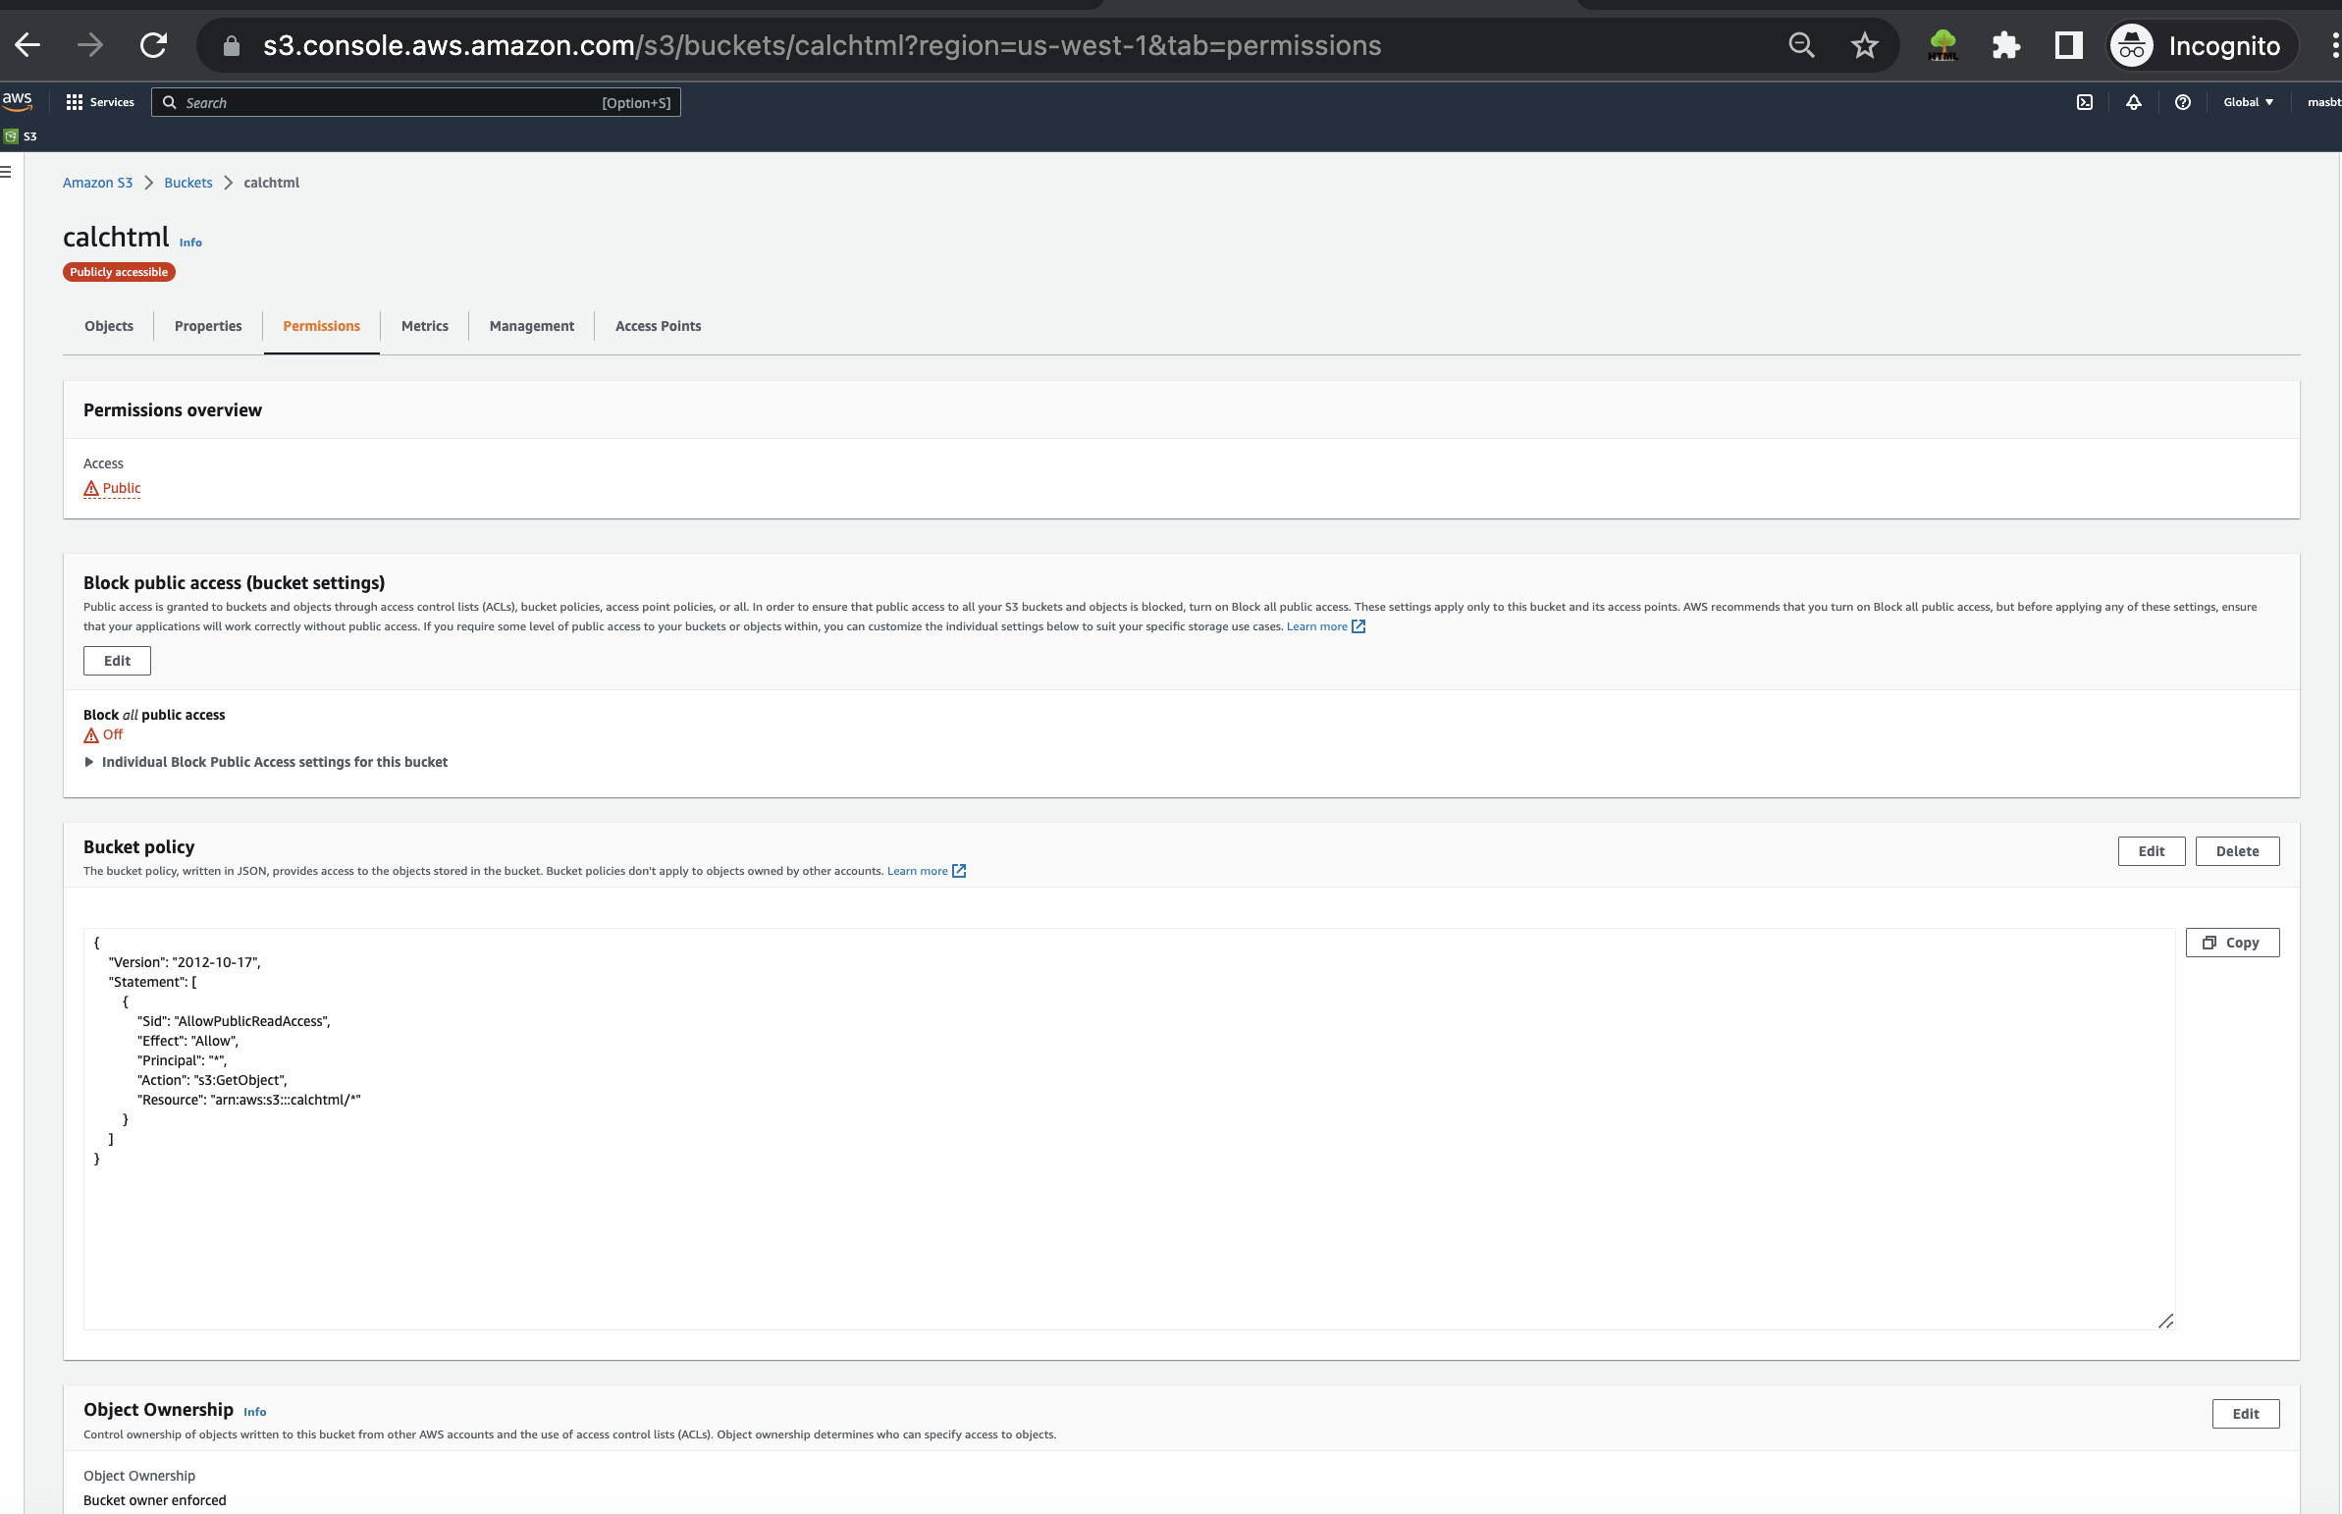

Save changes

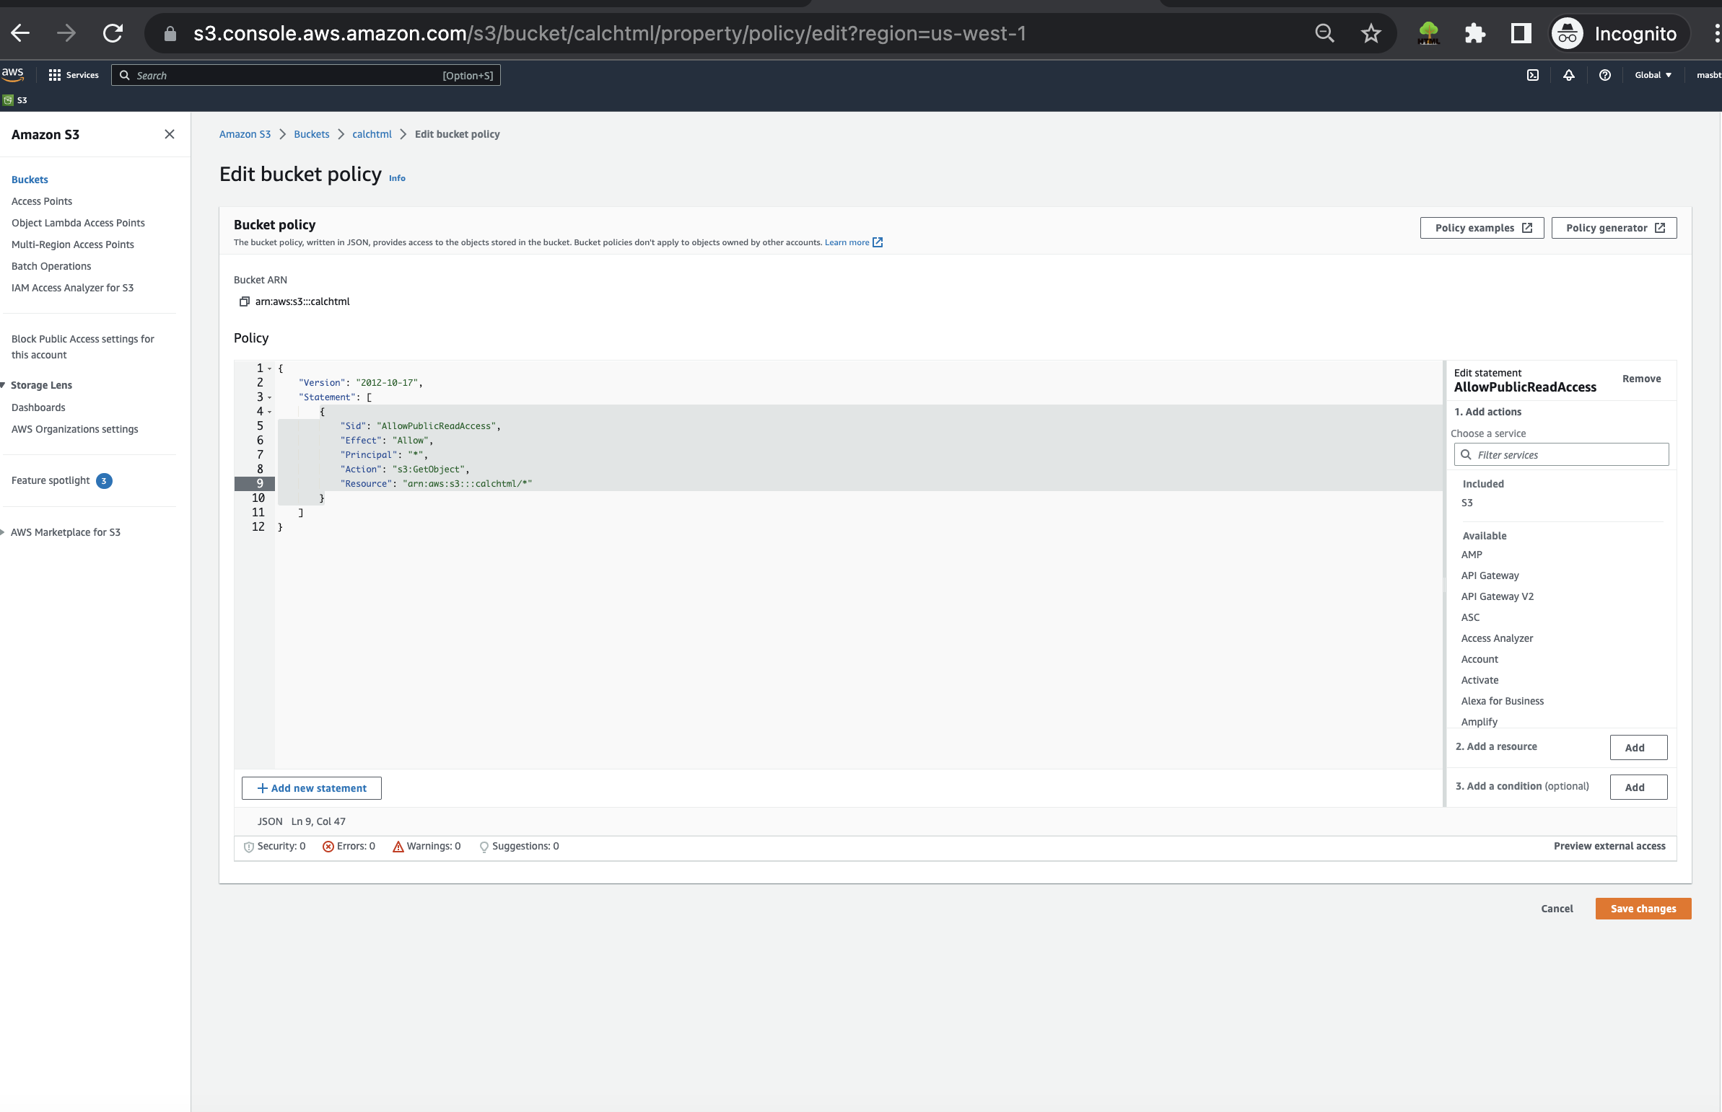

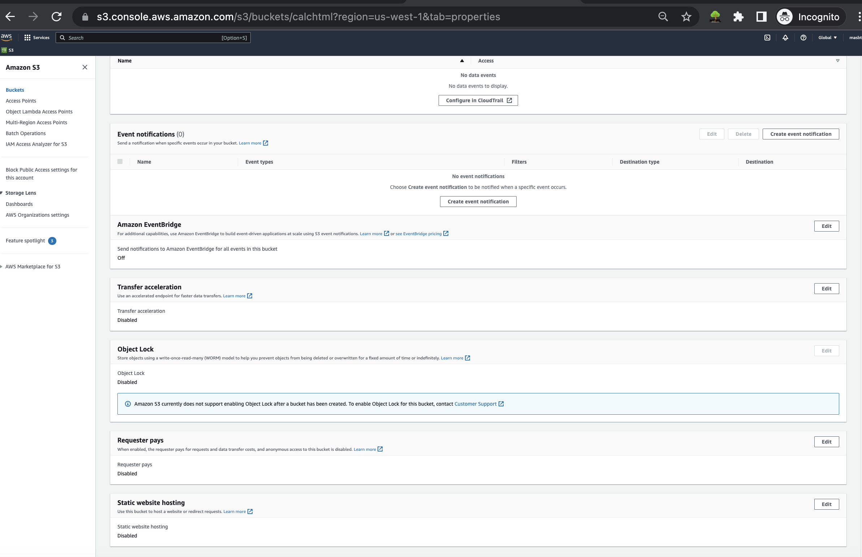

Going back to properties and scroll down for enable website statics

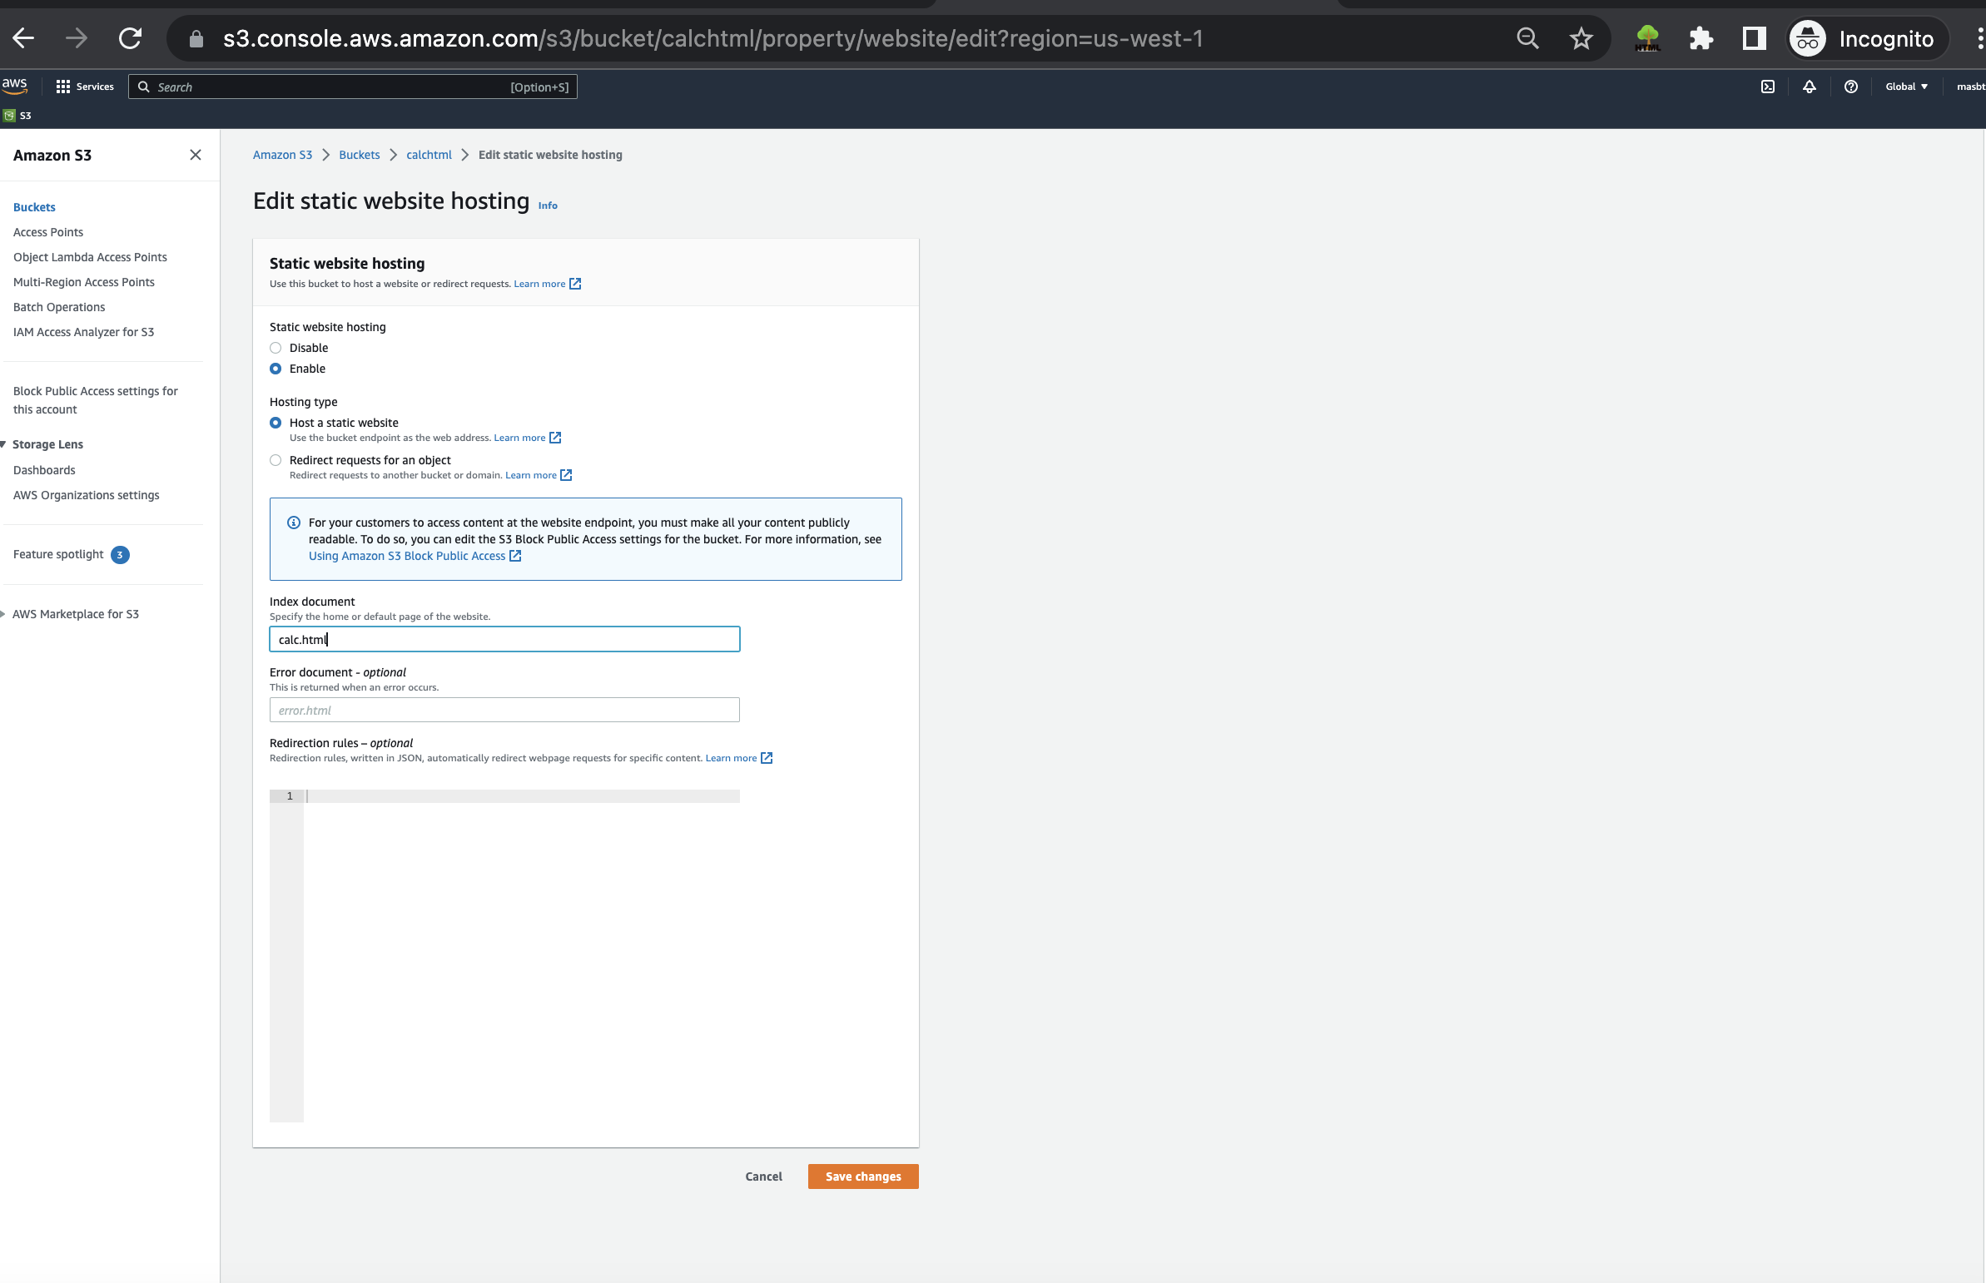

Choosing the website's name like our html file, then save it.

Now we have the website link.

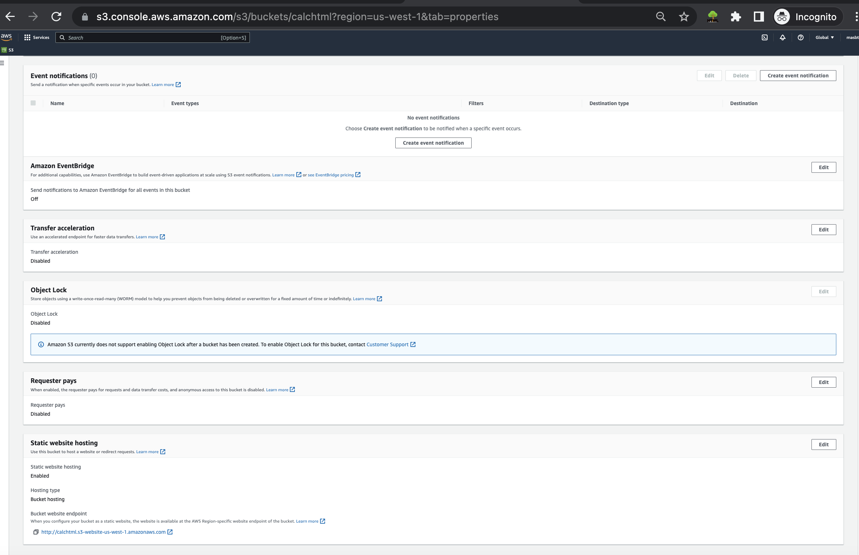

Open the html file and put our API URL

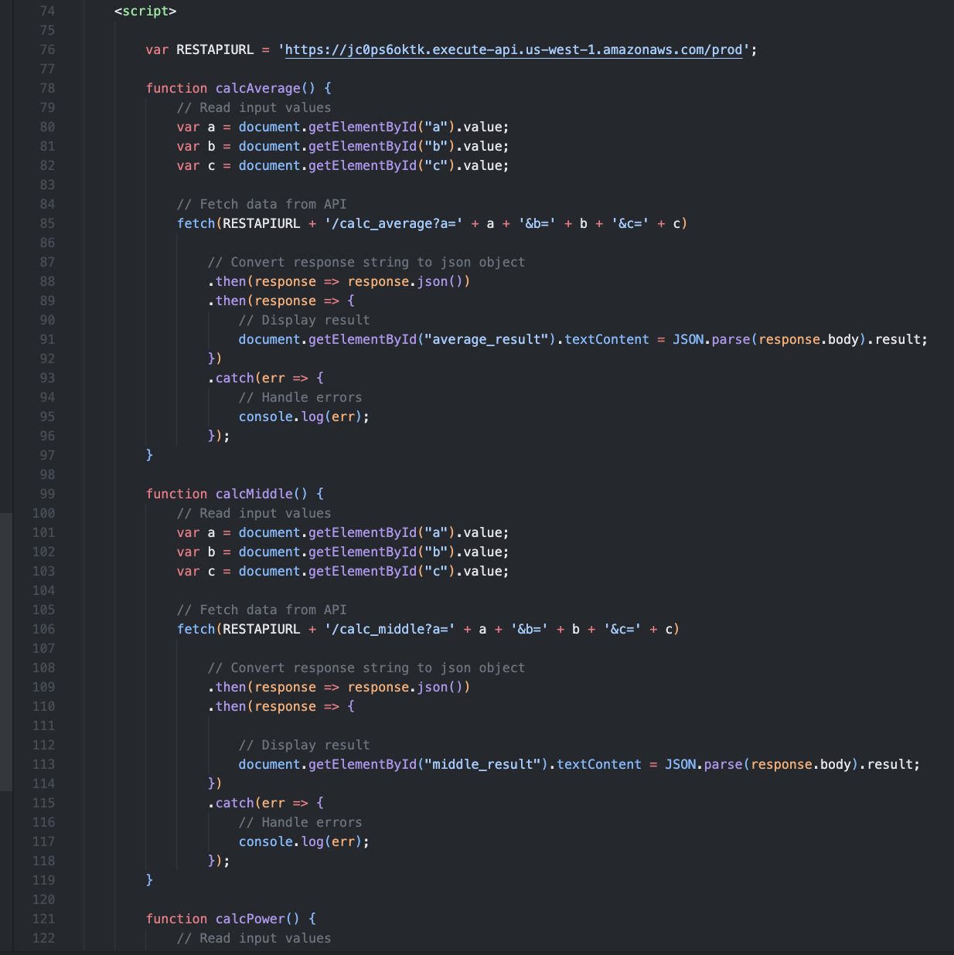

Going to objects and drag and upload our file which we updated recently. 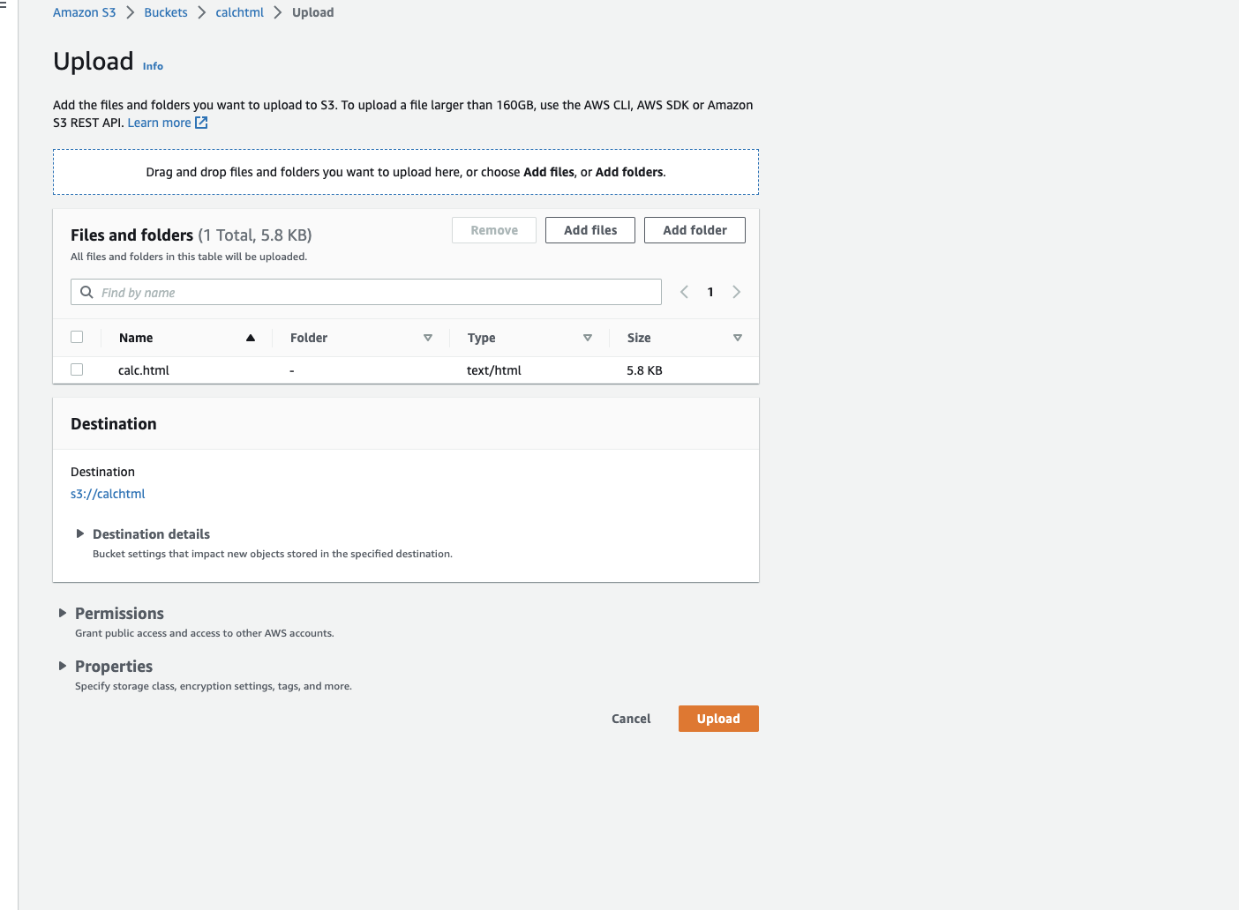

Now going to our website to test functions, with the same value early

<http://calchtml.s3-website-us-west-1.amazonaws.com>

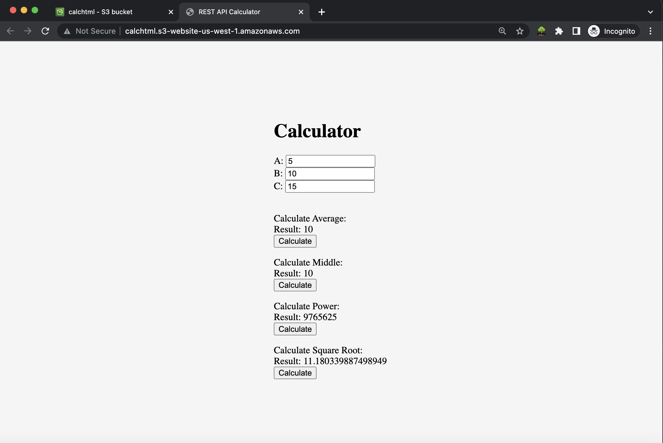

As we can see the same result properly and provide expected result.